## **Module 3 Activity 3: Middleware**

Saurabh Kale

IFT 458/554: Middleware Programming & Database Security

Dinesh Sthapit

Sep 24th, 2023

**Part A-**

**Hello World-**

**App.js-**

// require express use or import express

const express = require('express');

const app = express();

app.get('/', (req, res) => {

    res.send('Hello World');

});

app.listen(3000, () => {

    console.log('Server is running on port 3000');

});

**Code-**

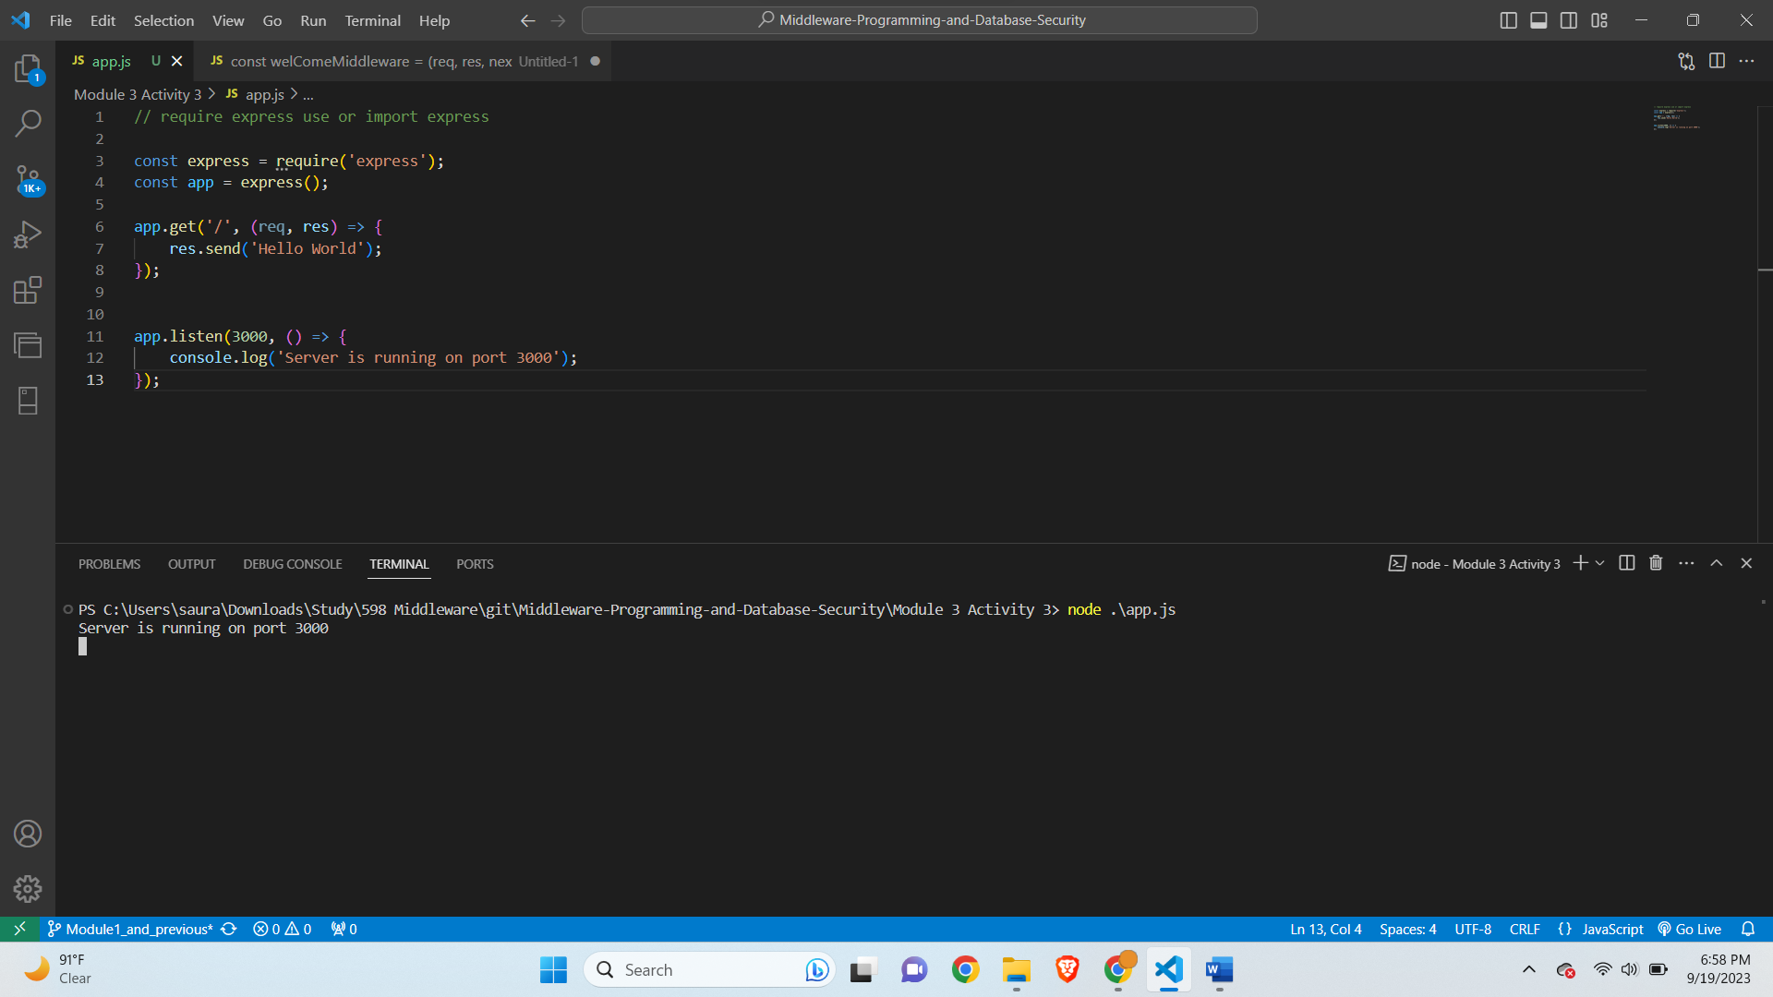

**Output-**

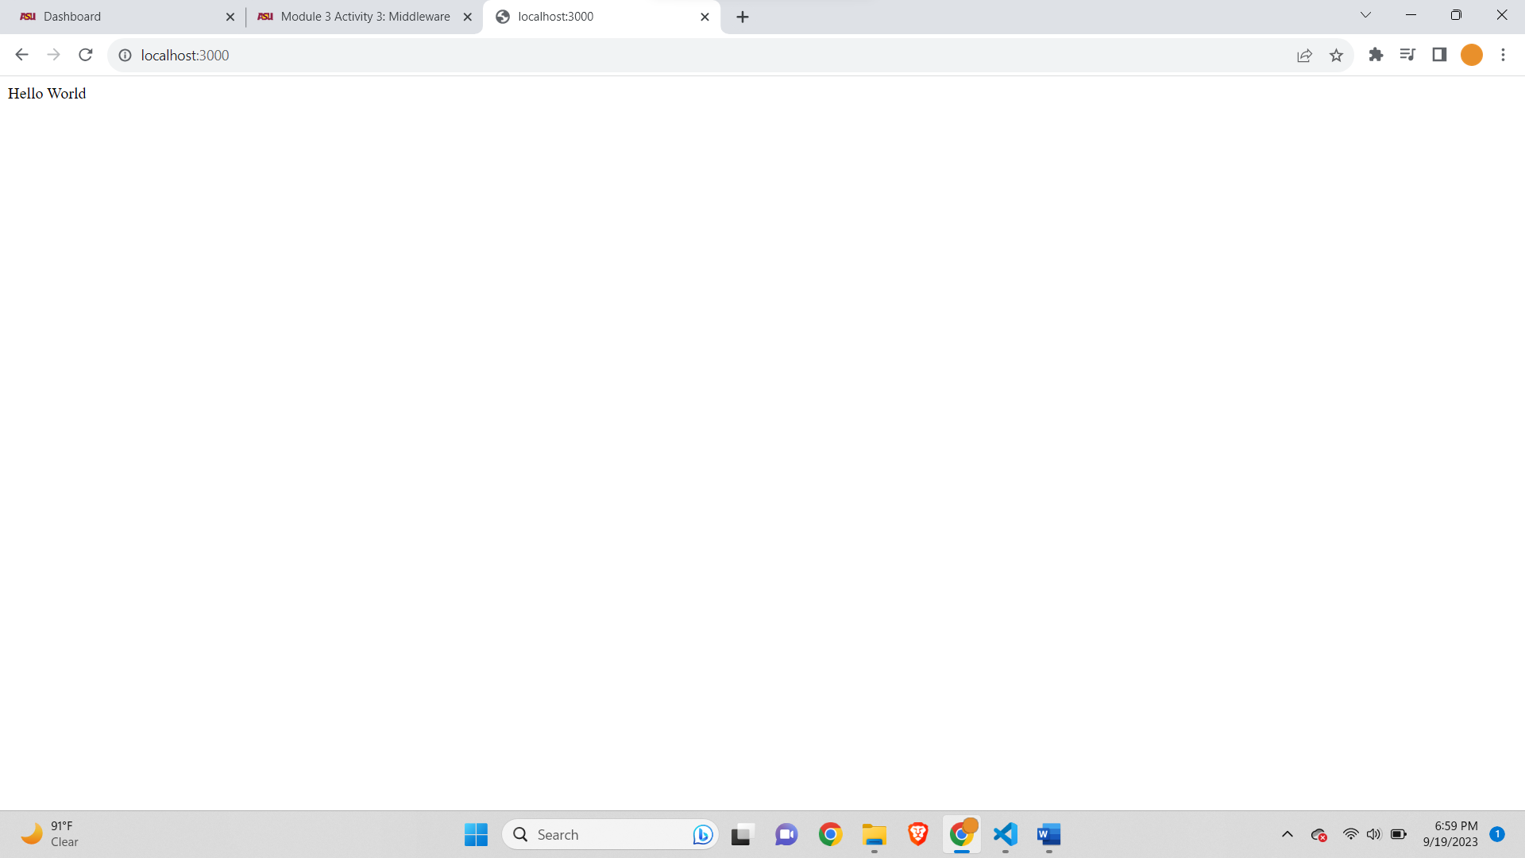

**WelcomeMiddleware Function-**

**App.js-**

// Name: Saurabh Kale

// ASUID: 1223450319

// Date: 9/24/2023

// require express use or import express

const express = require('express');

const app = express();

app.get('/', (req, res) => {

    res.send('Hello World');

});

const welComeMiddleware = (req, res, next) => {

    console.log('Welcome to my website');

    next();

}

app.use(welComeMiddleware);

app.listen(3000, () => {

    console.log('Server is running on port 3000');

});

**Code Screenshot-**

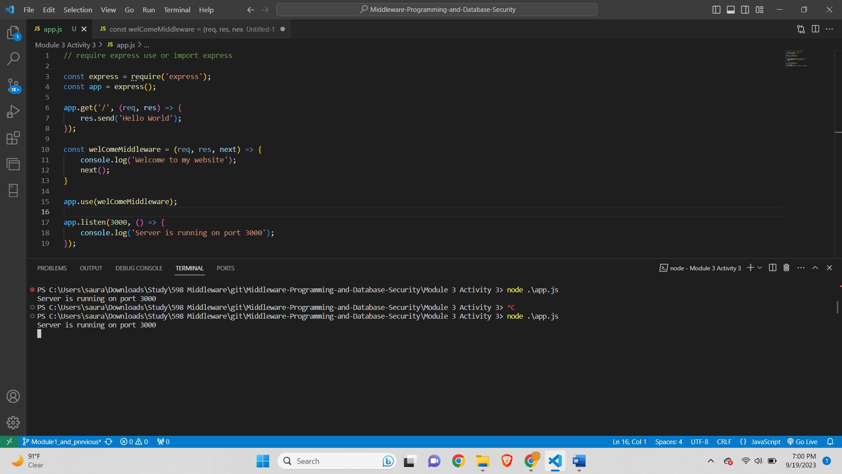

**Output Screenshot-**

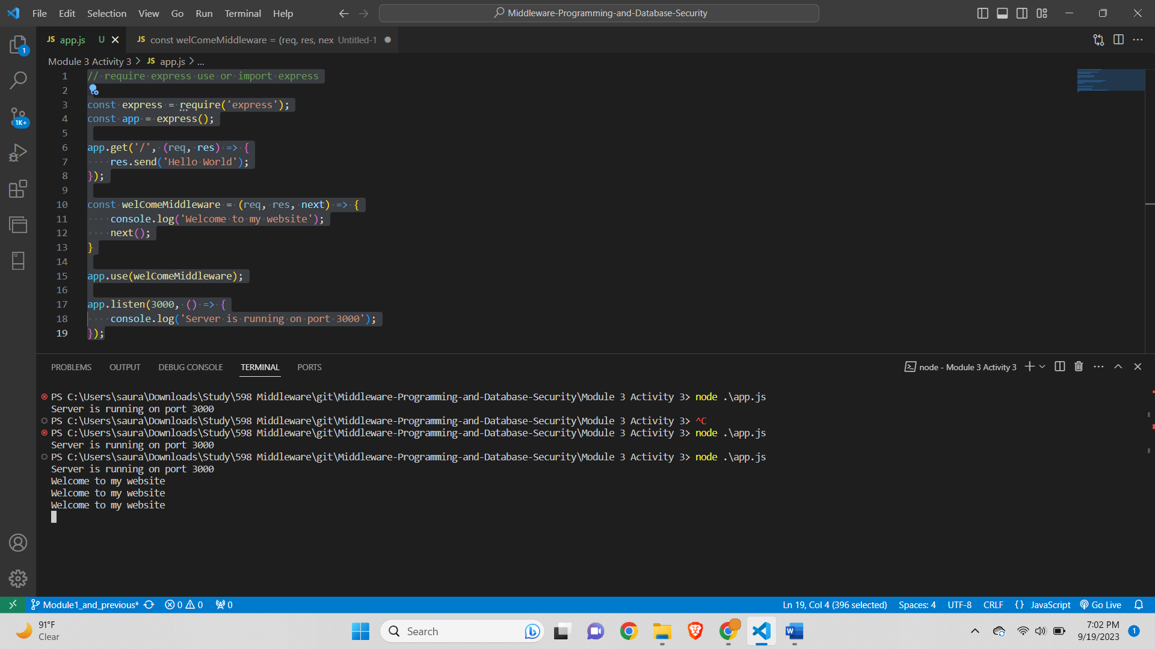

**CheckAdmin-**

**App.js-**

// Name: Saurabh Kale

// ASUID: 1223450319

// Date: 9/24/2023

// require express use or import express

const express = require('express');

const app = express();

const welComeMiddleware = (req, res, next) => {

    console.log('Welcome to my website');

    next();

}

const checkAdmin = (req, res, next) => {

    if(req.query.admin === 'true'){

        next();

    } else{

        res.status(400).send('Should be admin');

    }

}

app.use(welComeMiddleware);

app.use(checkAdmin);

app.get('/', (req, res) => {

    res.send('Hello World');

});

app.listen(3000, () => {

    console.log('Server is running on port 3000');

});

**Code Screenshot-**

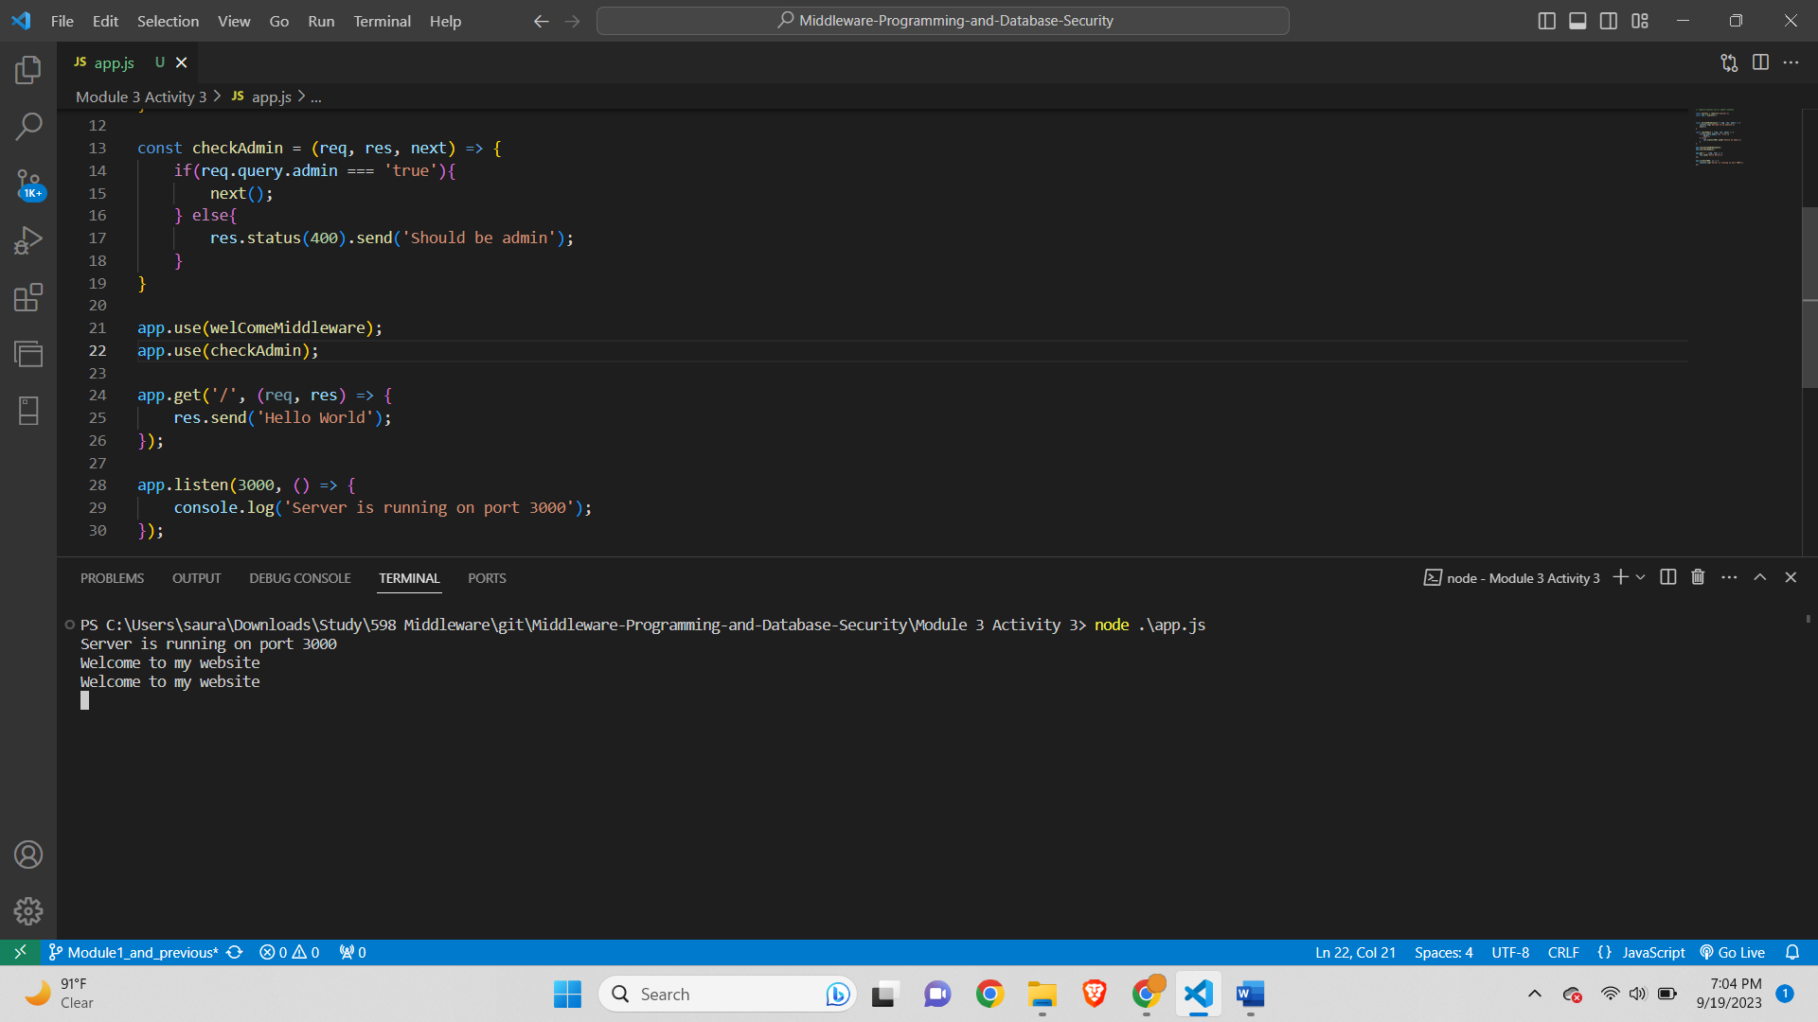

**Output Screenshot-**

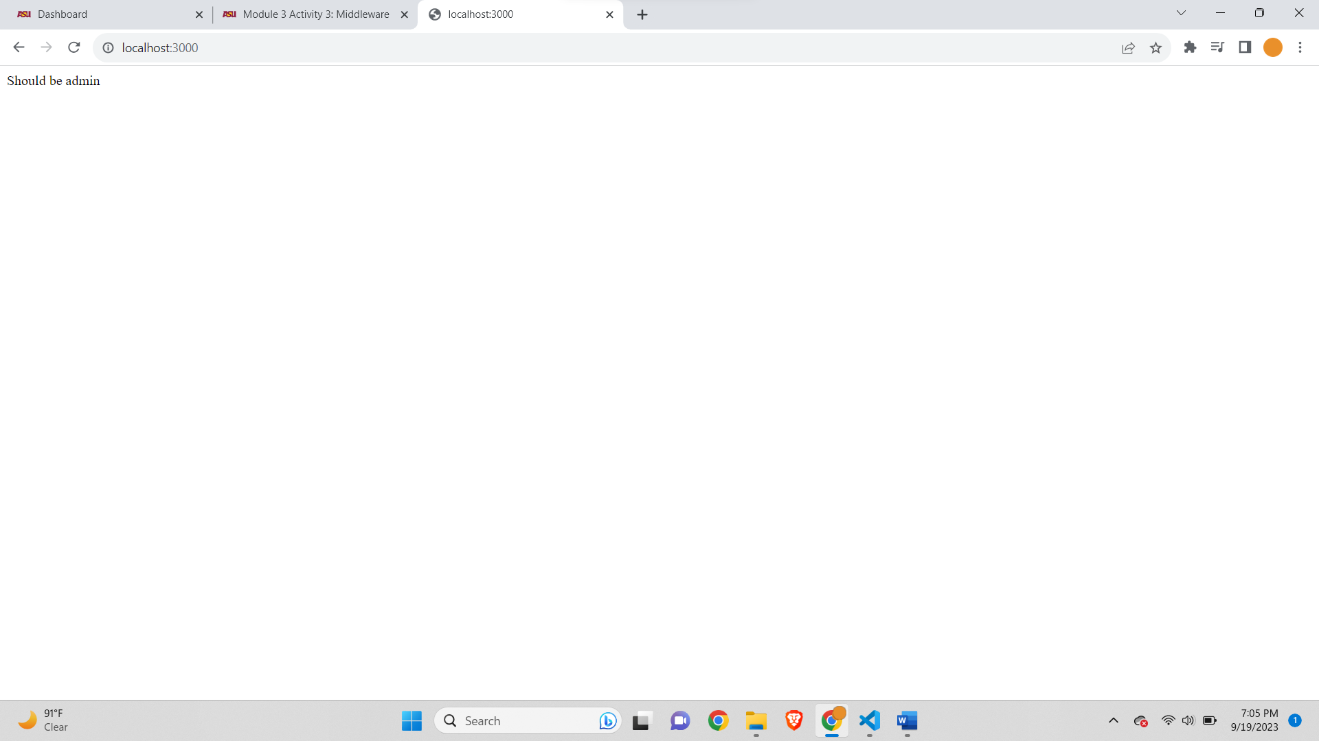

**Part A Debugging-**

**App.js-**

// Name: Saurabh Kale

// ASUID: 1223450319

// Date: 9/24/2023

// require express use or import express

const express = require('express');

const app = express();

const students = []; // array of students objects acting as storage

const bodyParser = require('body-parser');

app.use(bodyParser.json());

const getSpecificStudent = (req, res) => {

    const id = req.params.id;

    const currentStudent = students[id]

    res.send(`Student with the ${id} is ${currentStudent.fname} ${currentStudent.mname} ${currentStudent.lname}`);

}

const getStudents = (req, res) => {

    res.send(students);

}

const addStudent = (req, res) => {

    const student = req.body;

    students.push(student);

    res.send(`Student with the name ${student.fname} ${student.mname} ${student.lname} added to the database`);

}

const updateStudent = (req, res) => {

    const id = req.params.id;

    const student = req.body;

    students[id] = student;

    res.send(`Student with the id ${id} has been updated`);

}

const deleteStudent = (req, res) => {

    const id = req.params.id;

    const student = students[id];

    student.splice(id, 1);

    res.send(`Student with the id ${id} has been deleted`);

}

//  routes handlers CRUD interfaces

//  for every request, we have a response

app.get('/students/:id', getSpecificStudent); // get all students functions

app.get('/students', getStudents); // get all students functions

app.post('/students', addStudent); // add student function

app.put('/students/:id', updateStudent); //update student function

app.delete('/students/:id', deleteStudent); //delete student function

app.use('/', function(req, res, next) {

    console.log('Request Url:' + req.url);

    res.send('Hello');

});

app.listen(3000, () => {

    console.log('Server is running on port 3000');

});

**Debug for GET students-**

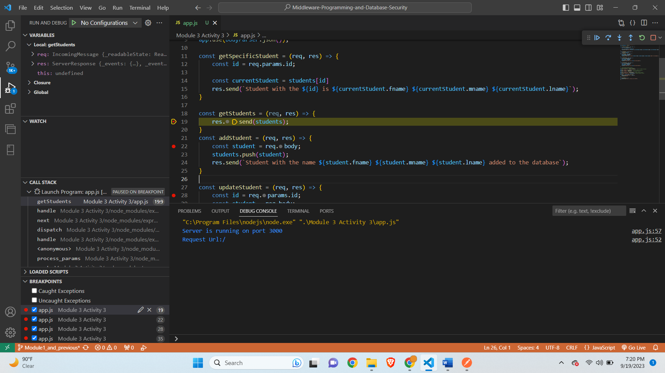

**Postman-**

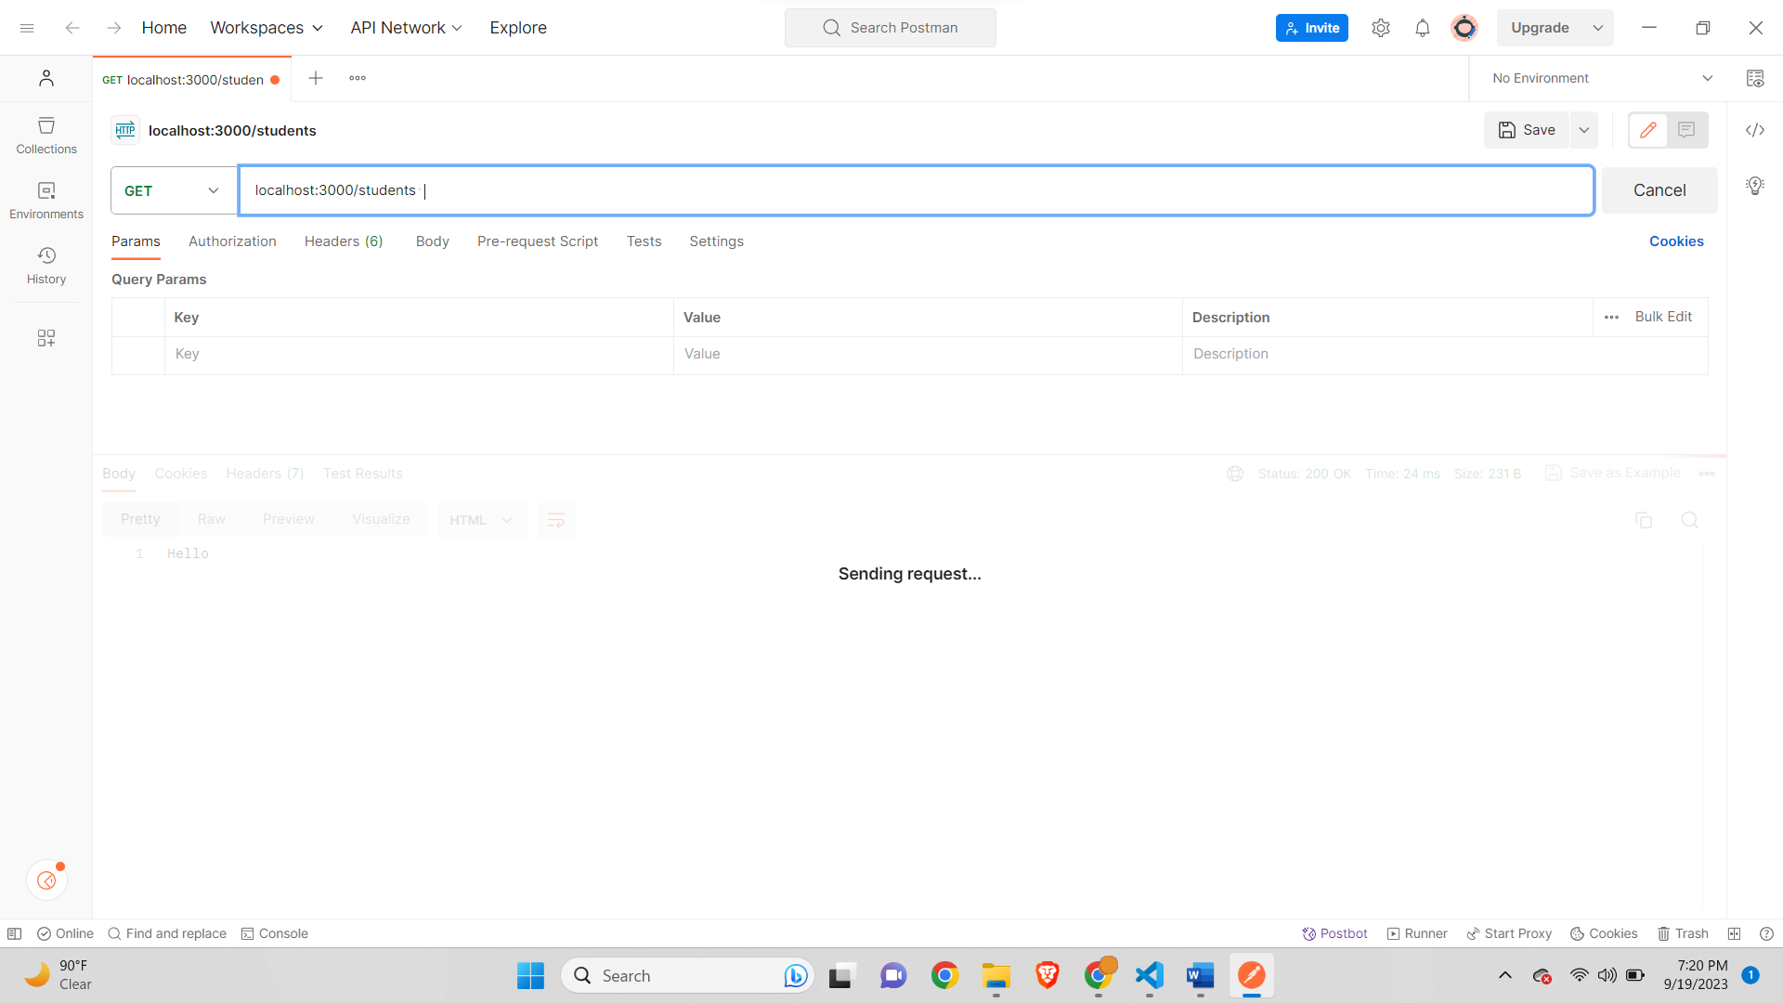

**After leaving Debugger-**

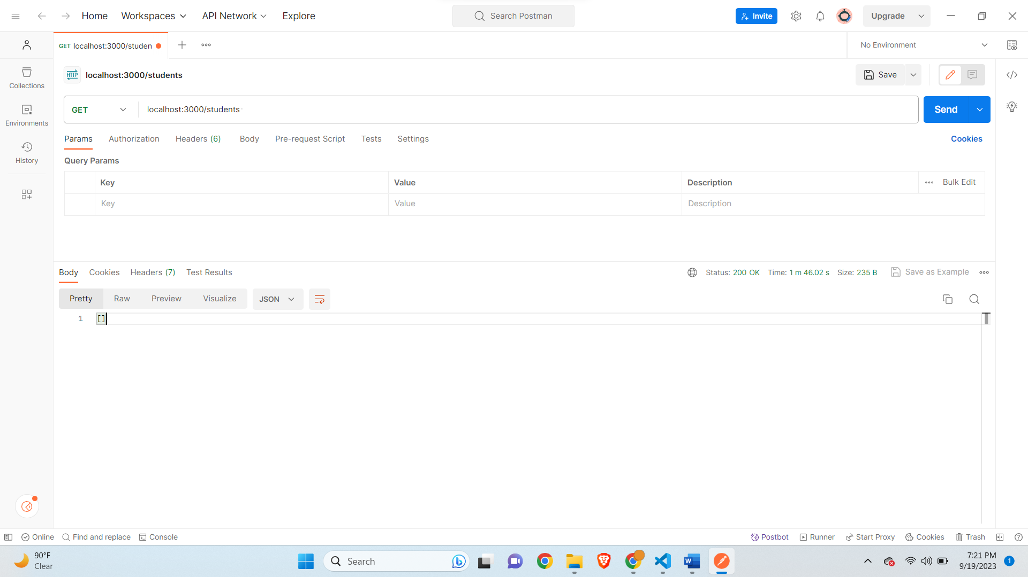

**POST Student-**

**Object in body in Postman-**

{

    "fname":"jake",

    "mname":"m",

    "lname":"moore",

    "age": 8,

    "address": "302 Main Street",

    "cell":"480-890-8811"

}

**Debugger stuck-**

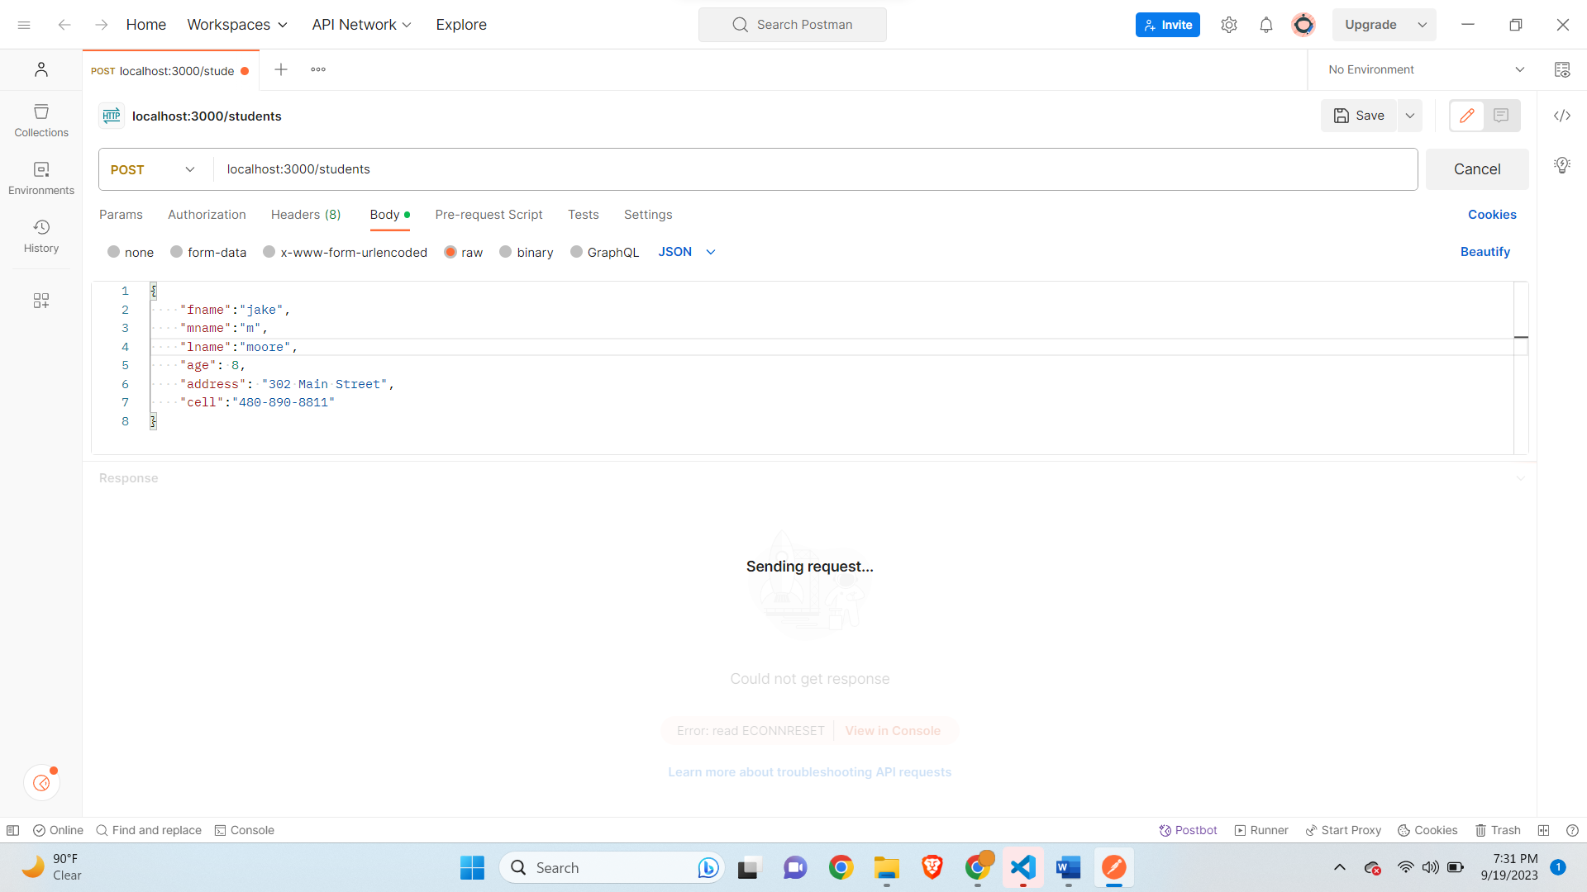

**Code Debugger-**

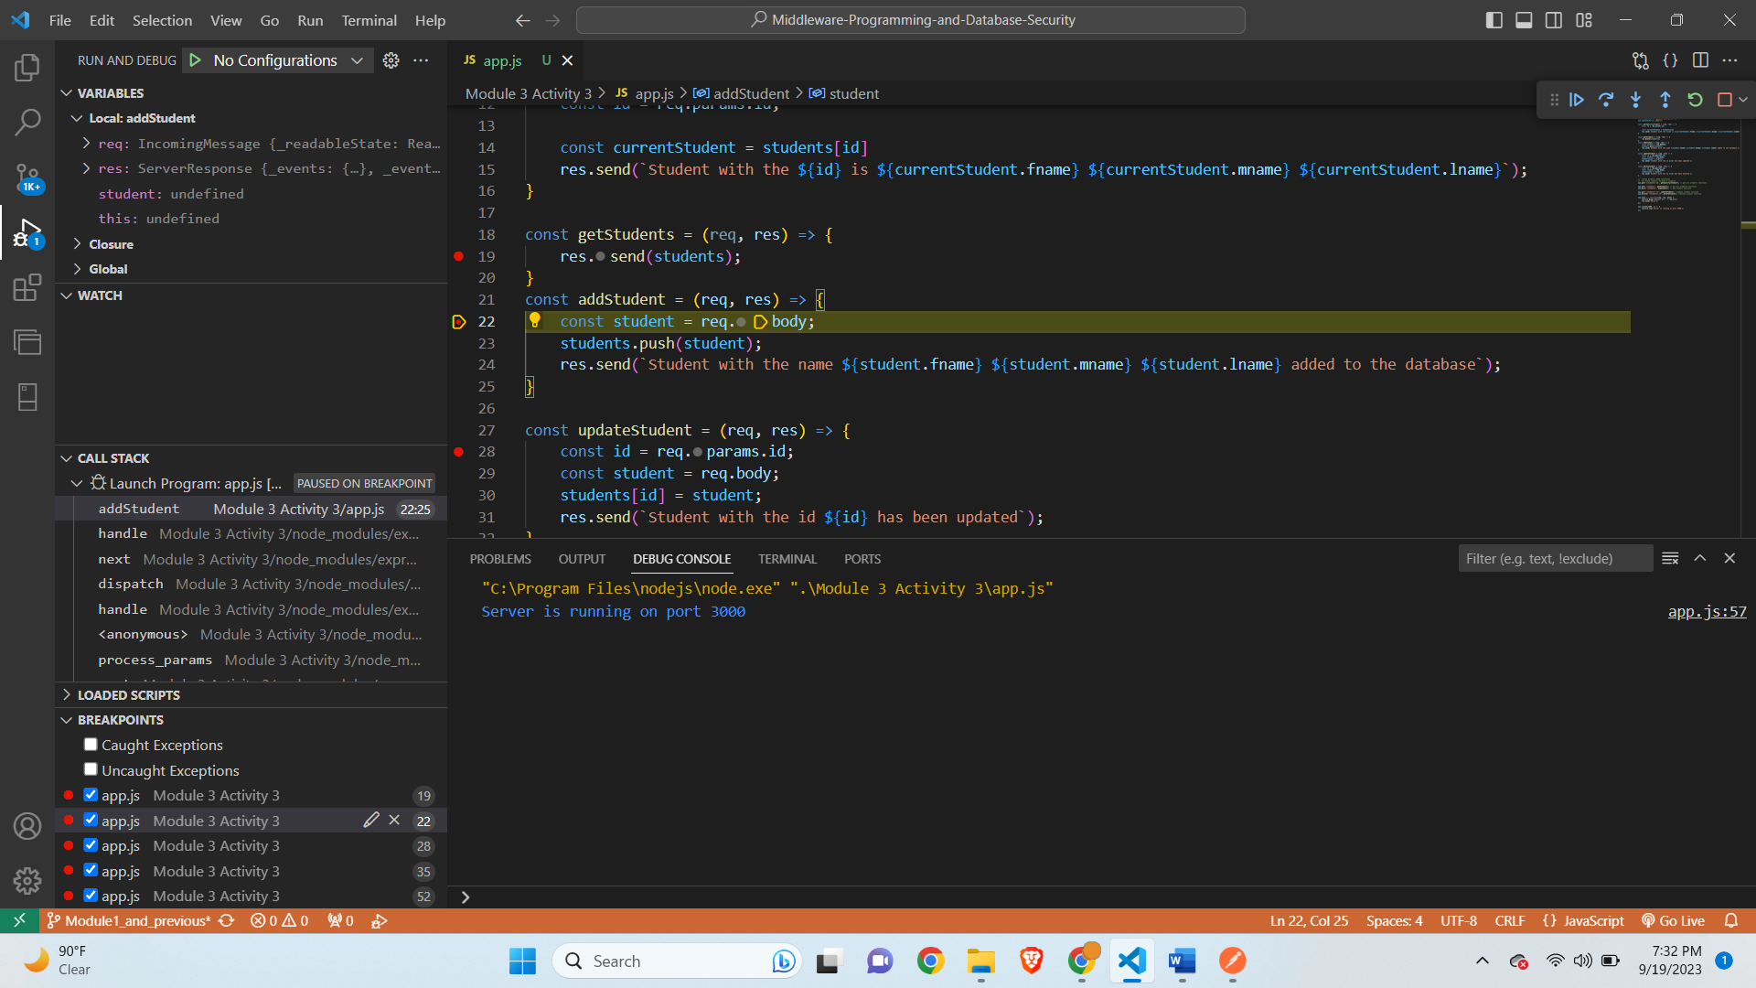

**After Leaving Debugger-**

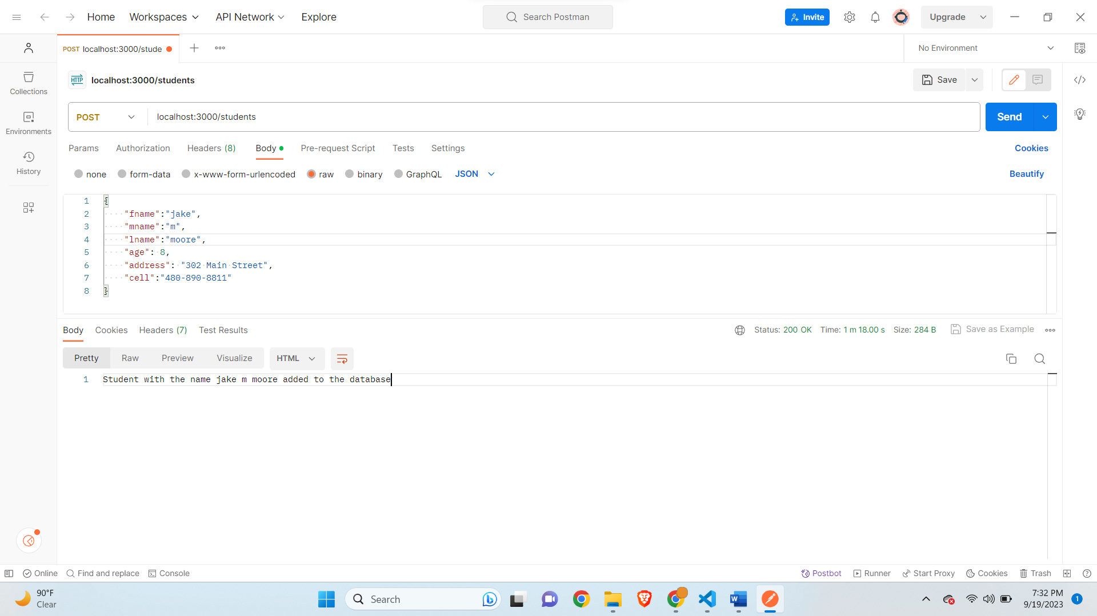

**Get students after adding student-**

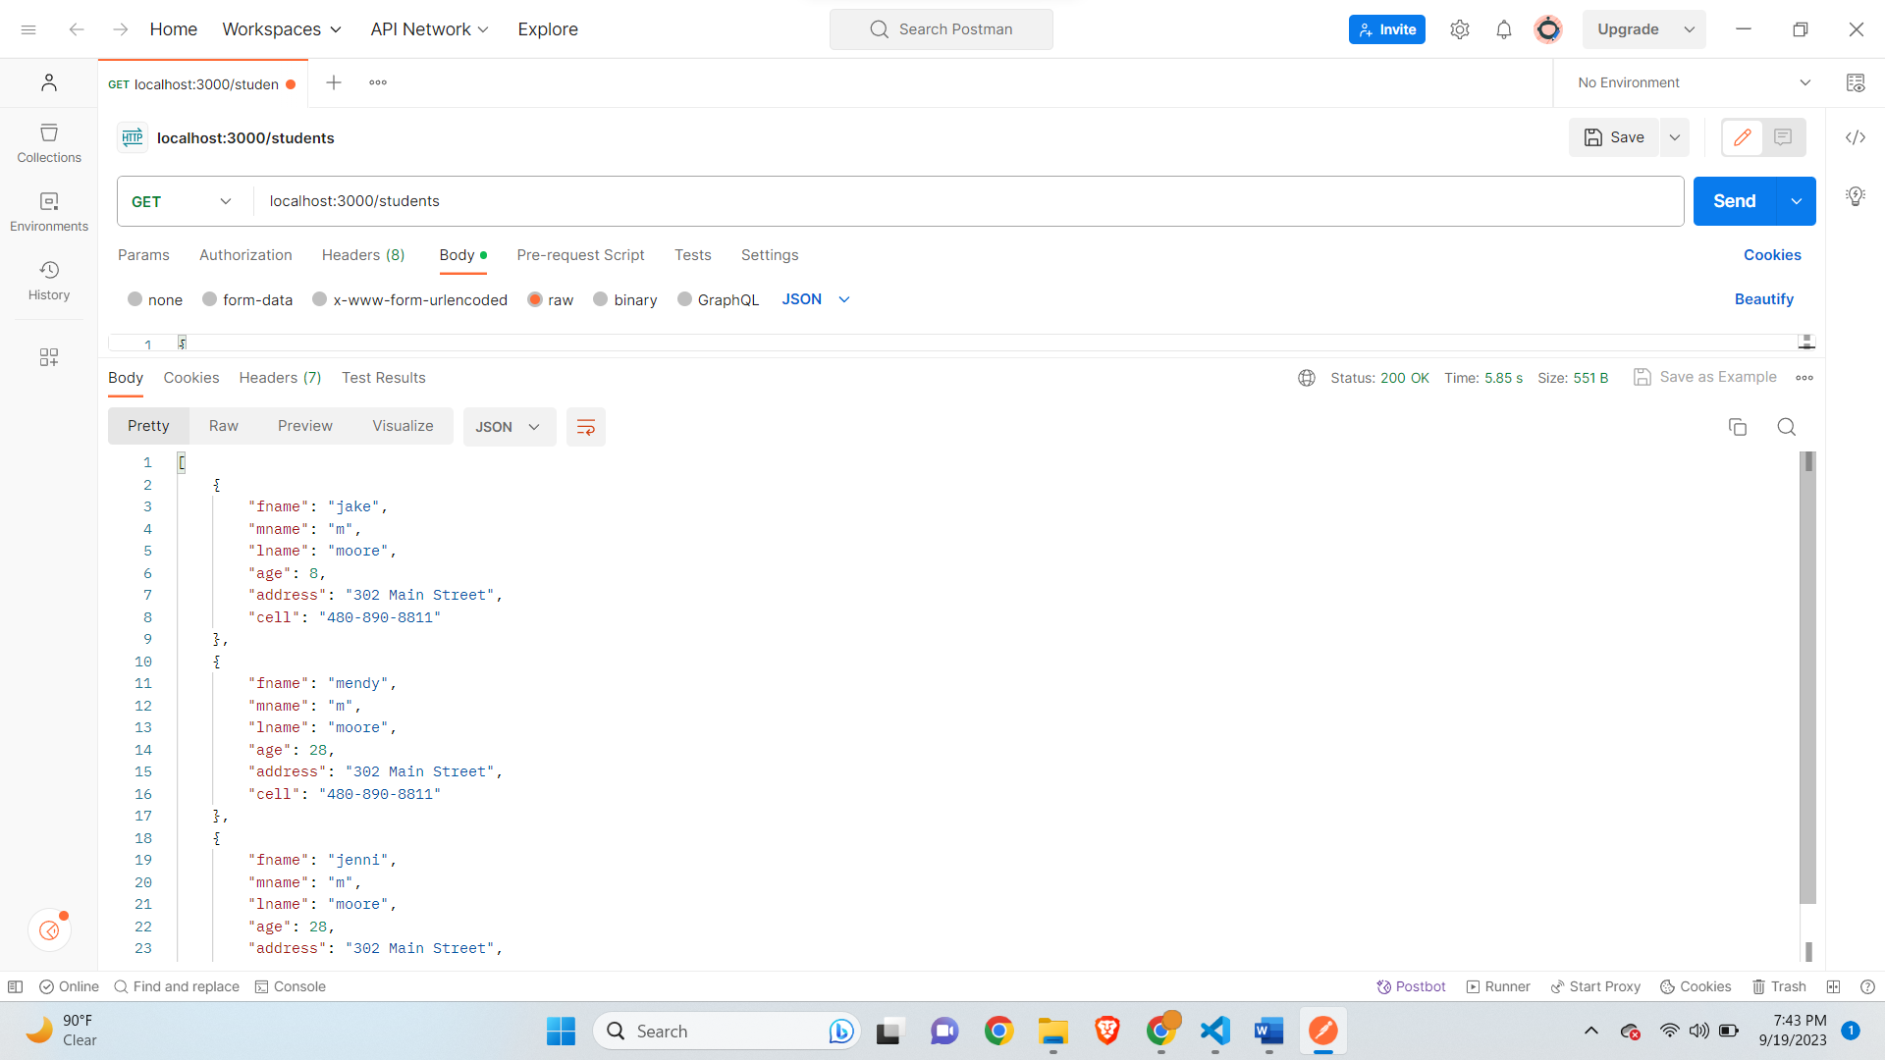

**PUT for student stuck in debugger-**

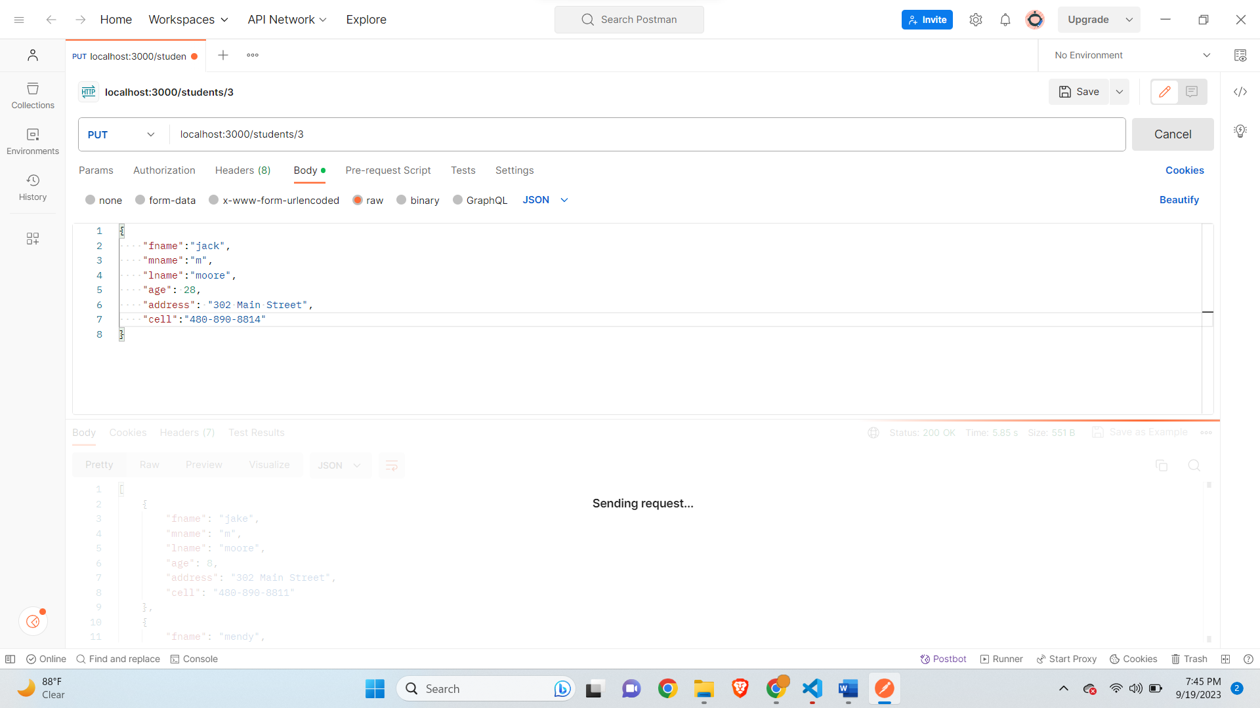

**Debugger stuck in code-**

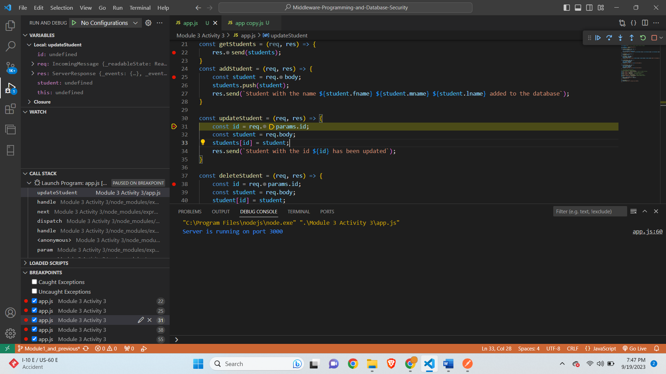

**After Leaving Debugger-**

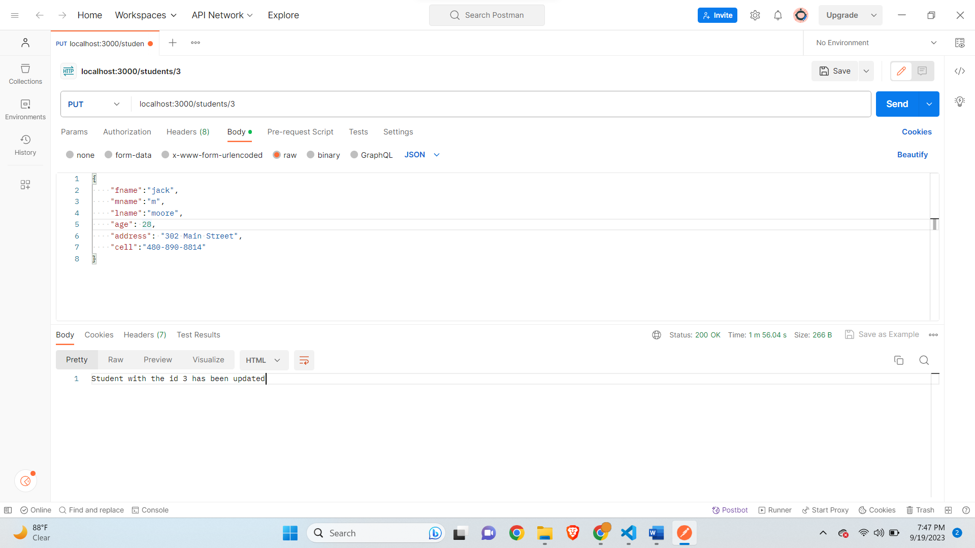

**Get Specific Student with Id stuck in debugger-**

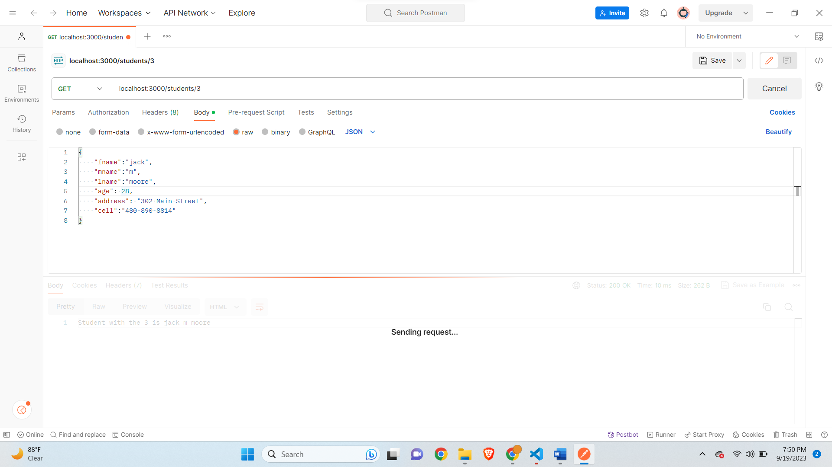

**Stuck in debugger for specific Id-**

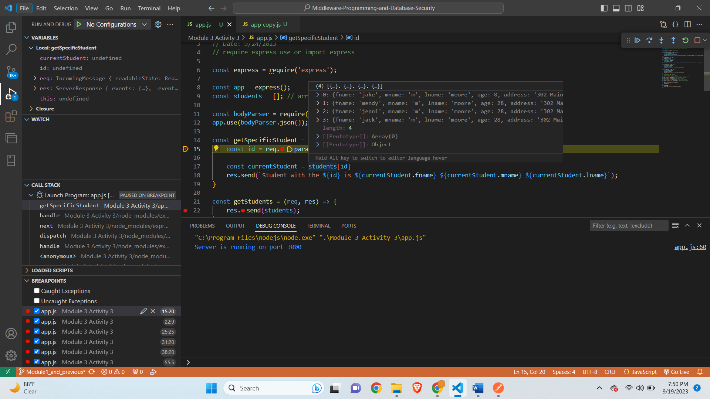

**After leaving debugger-**

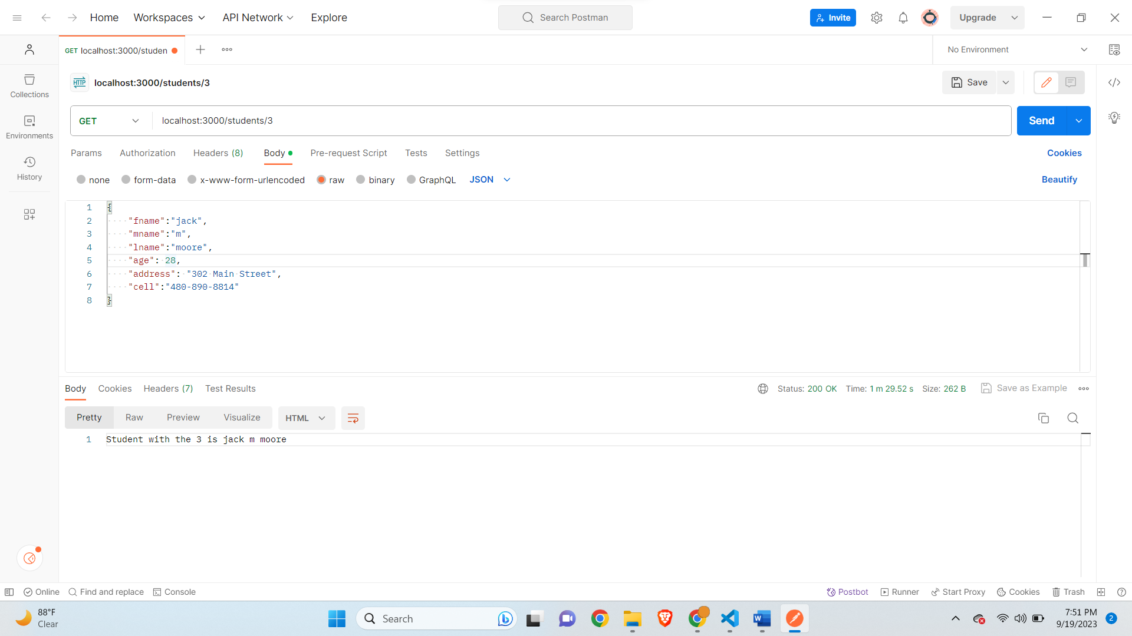

**Debugger Stuck for students get-**

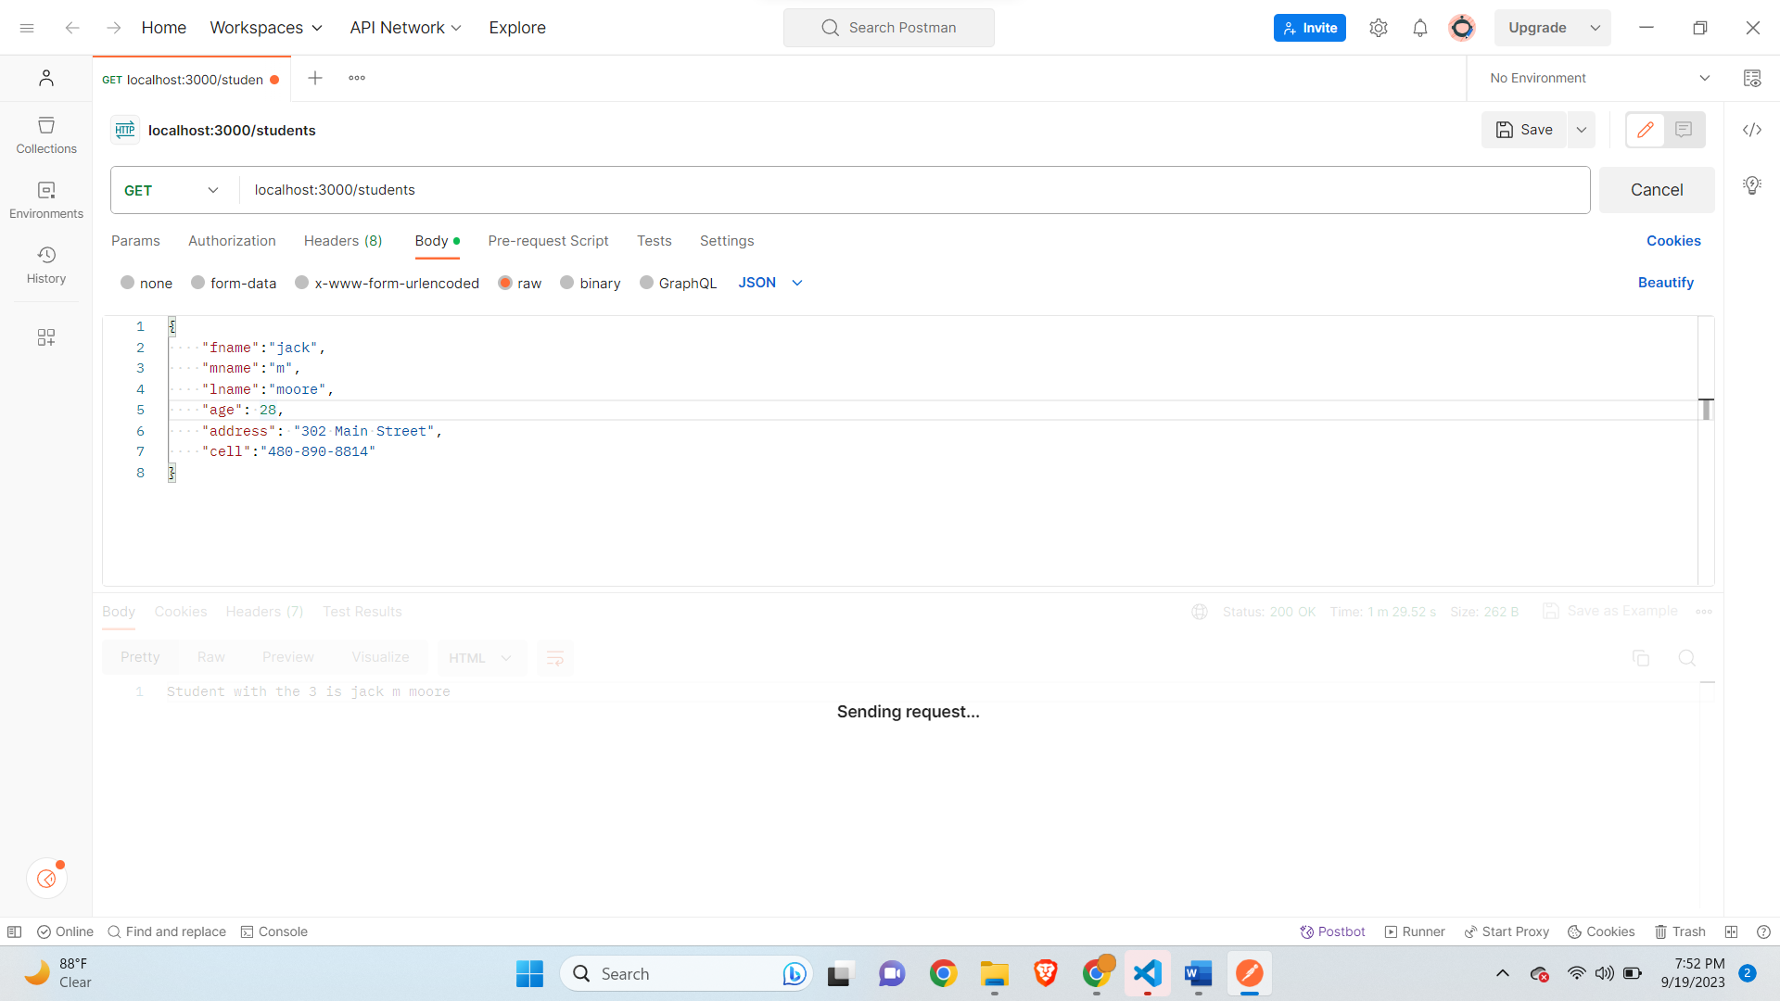

**Debugger in code-**

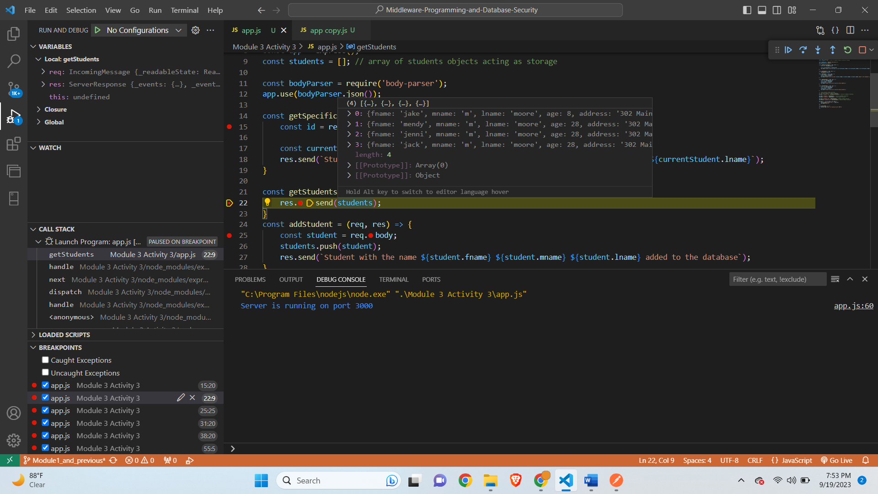

**After leaving Debugger-**

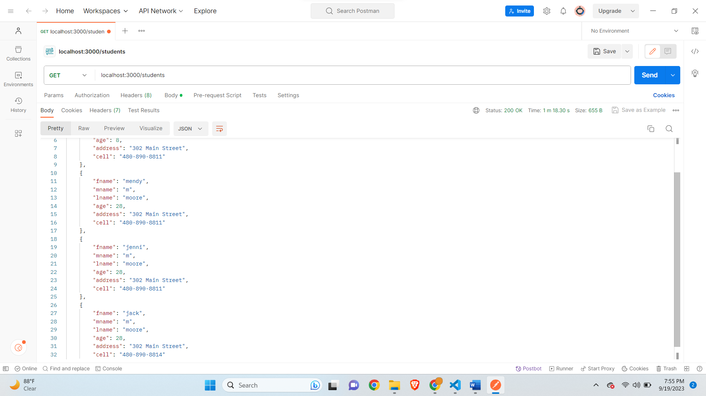

**Delete for Specific Student Debugger stuck-**

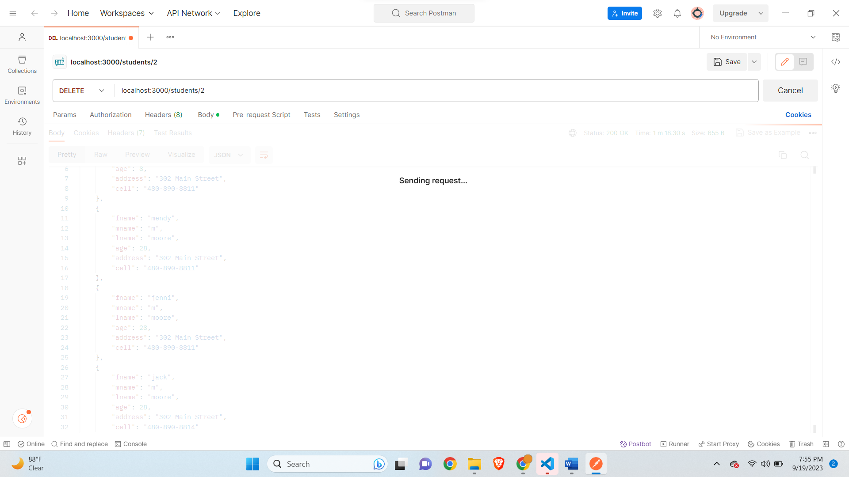

**Delete for specific student code debugger stuck-**

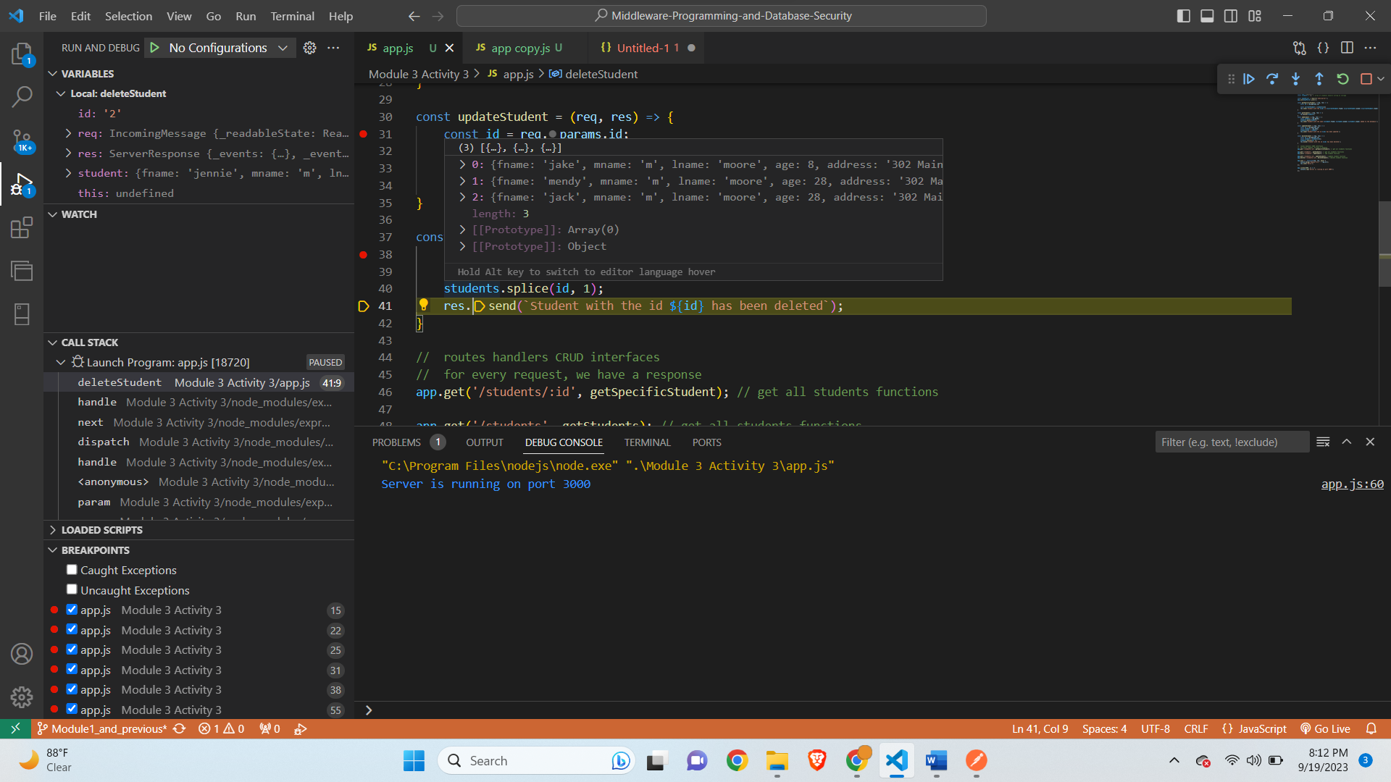

**After leaving debugger-**

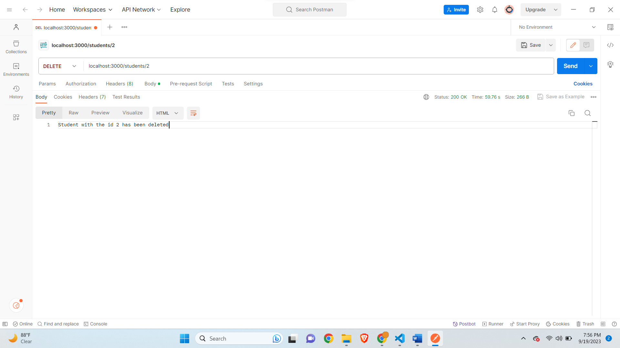

**Get All students-**

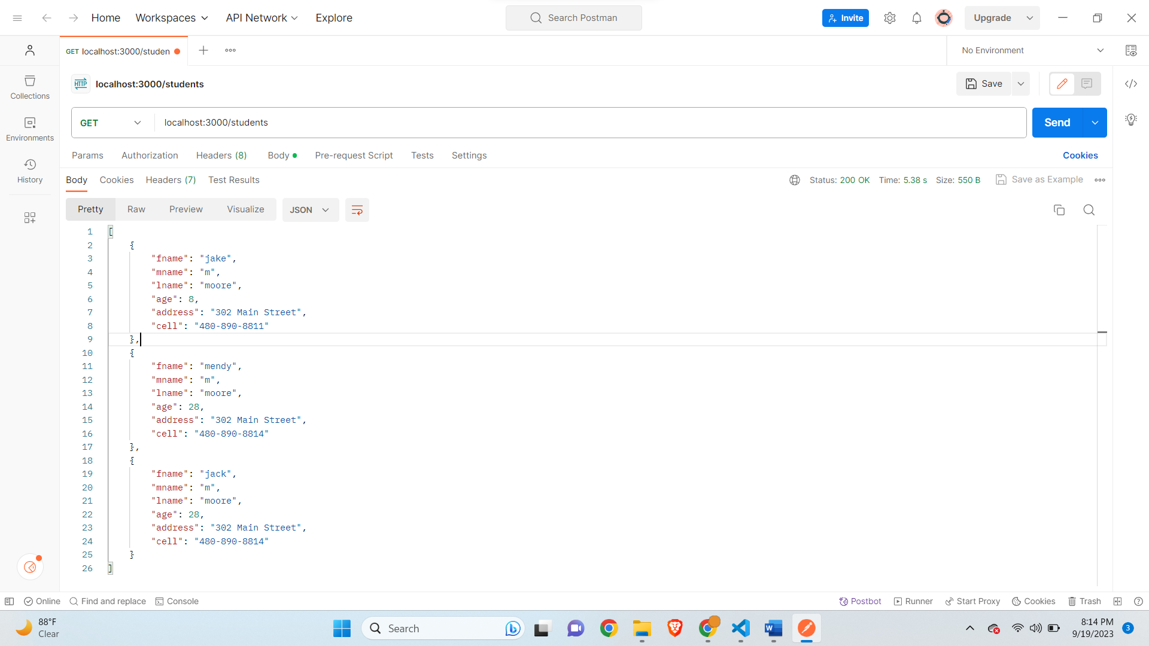

**Delete student with id 0-**

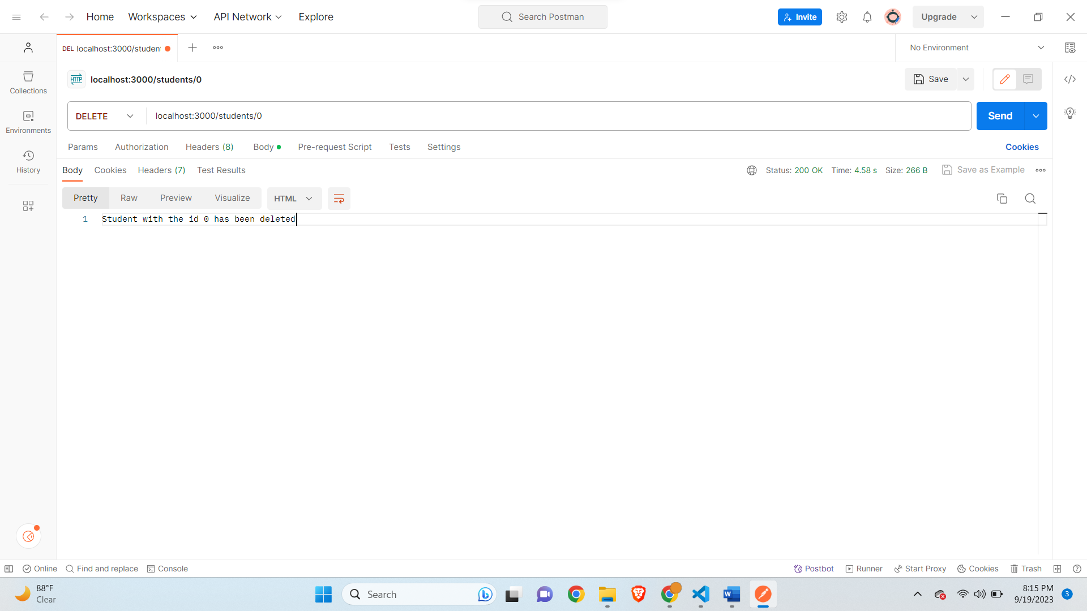

**Get all Students-**

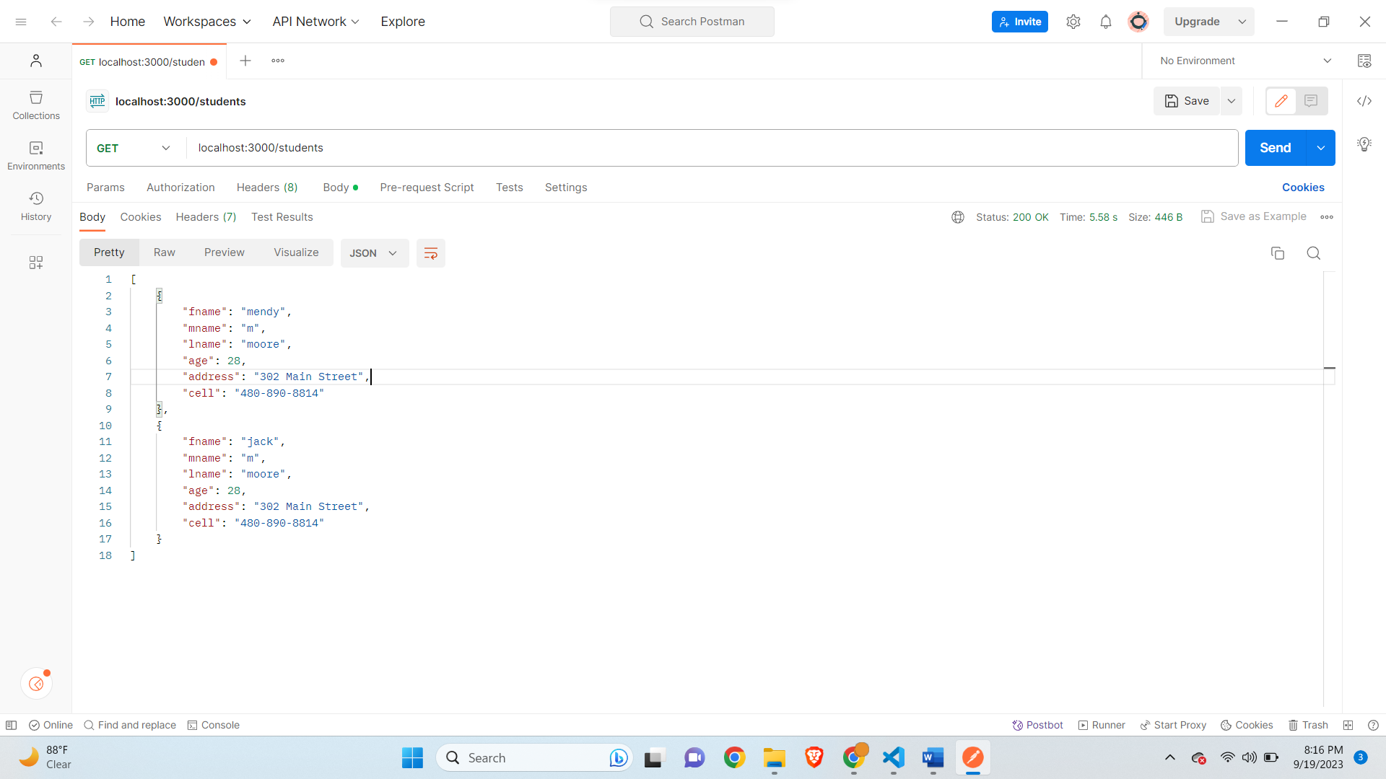

**Getting error for id which is not present-**

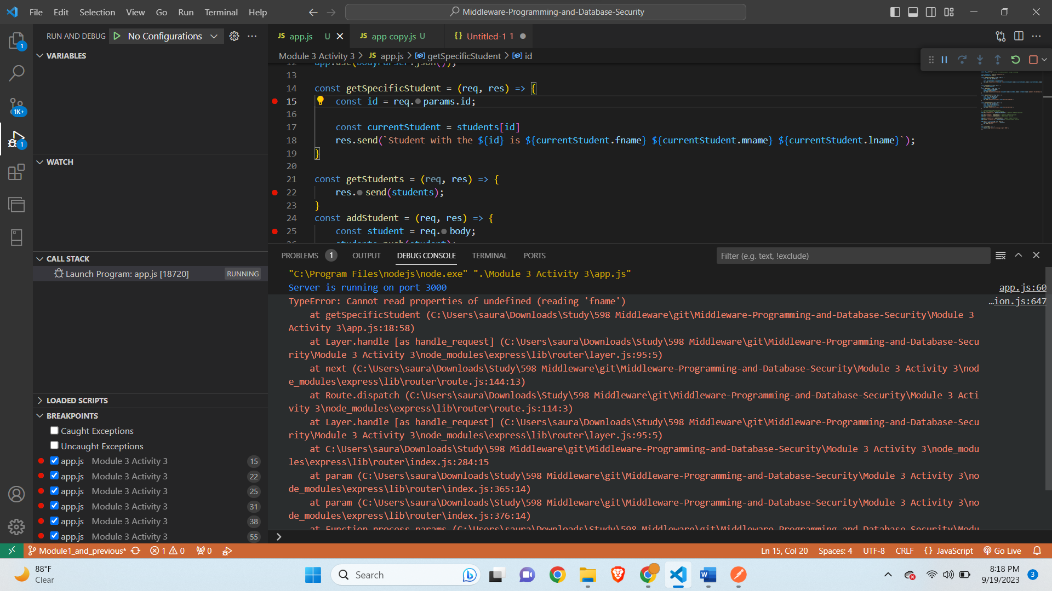

**Handling the error condition-**

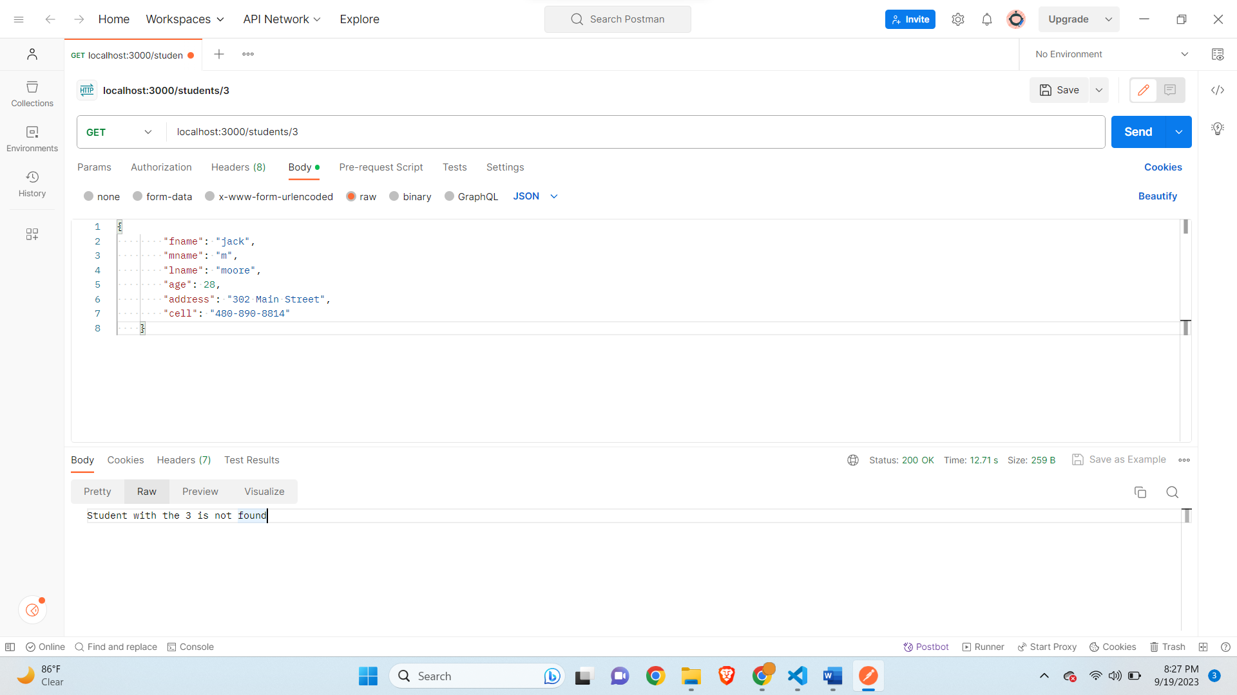

**Part B-**

**App.js Updated Code-**

// Name: Saurabh Kale

// ASUID: 1223450319

// Date: 9/24/2023

// require express use or import express

const express = require('express');

const app = express();

const students = []; // array of students objects acting as storage

const bodyParser = require('body-parser');

app.use(bodyParser.json());

//change the name to uppercase

const makeUpperCase = (req, res, next) => {

    const student = req.body;

    if(req.body.fname == undefined || req.body.mname == undefined || req.body.lname == undefined){

        return res.send('Please enter a valid name');

    }

    req.body.fname = student.fname.toUpperCase();

    req.body.mname = student.mname.toUpperCase();

    req.body.lname = student.lname.toUpperCase();

    next();

}

app.use(makeUpperCase);

const getSpecificStudent = (req, res) => {

    const id = req.params.id;

    const currentStudent = students[id]

    if(currentStudent === undefined){

        res.send(`Student with the ${id} is not found`)

    }

    res.send(`Student with the ${id} is ${currentStudent.fname} ${currentStudent.mname} ${currentStudent.lname}`);

}

const getStudents = (req, res) => {

    res.send(students);

}

const addStudent = (req, res) => {

    const student = req.body;

    students.push(student);

    res.send(`Student with the name ${student.fname} ${student.mname} ${student.lname} added to the database`);

}

const updateStudent = (req, res) => {

    const id = req.params.id;

    const student = req.body;

    students[id] = student;

    res.send(`Student with the id ${id} has been updated`);

}

const deleteStudent = (req, res) => {

    const id = req.params.id;

    const student = students[id];

    students.splice(id, 1);

    res.send(`Student with the id ${id} has been deleted`);

}

//  routes handlers CRUD interfaces

//  for every request, we have a response

app.get('/students/:id', getSpecificStudent); // get all students functions

app.get('/students', getStudents); // get all students functions

app.post('/students', addStudent); // add student function

app.put('/students/:id', updateStudent); //update student function

app.delete('/students/:id', deleteStudent); //delete student function

app.use('/', function(req, res, next) {

    console.log('Request Url:' + req.url);

    res.send('Hello');

});

app.listen(3000, () => {

    console.log('Server is running on port 3000');

});

**Debugger in upper case-**

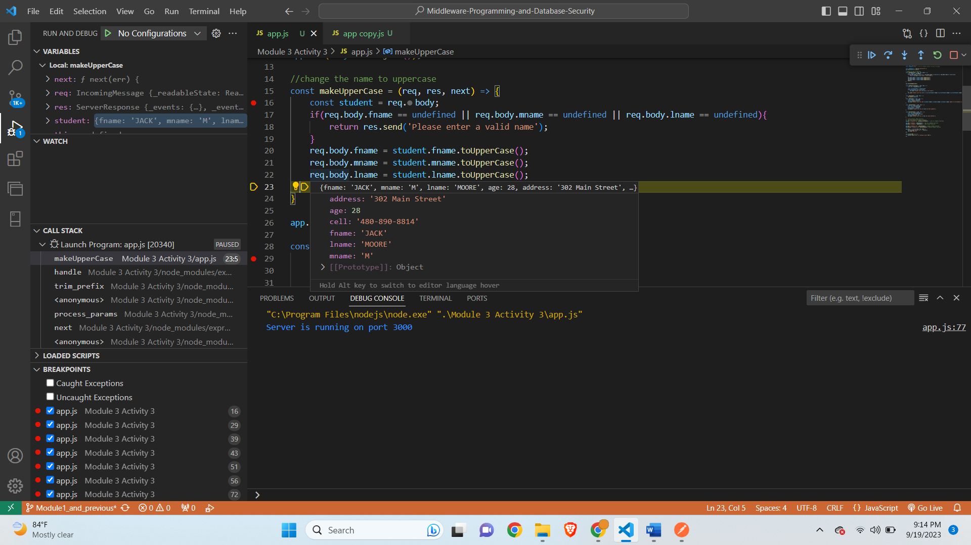

**After continuing debugger-**

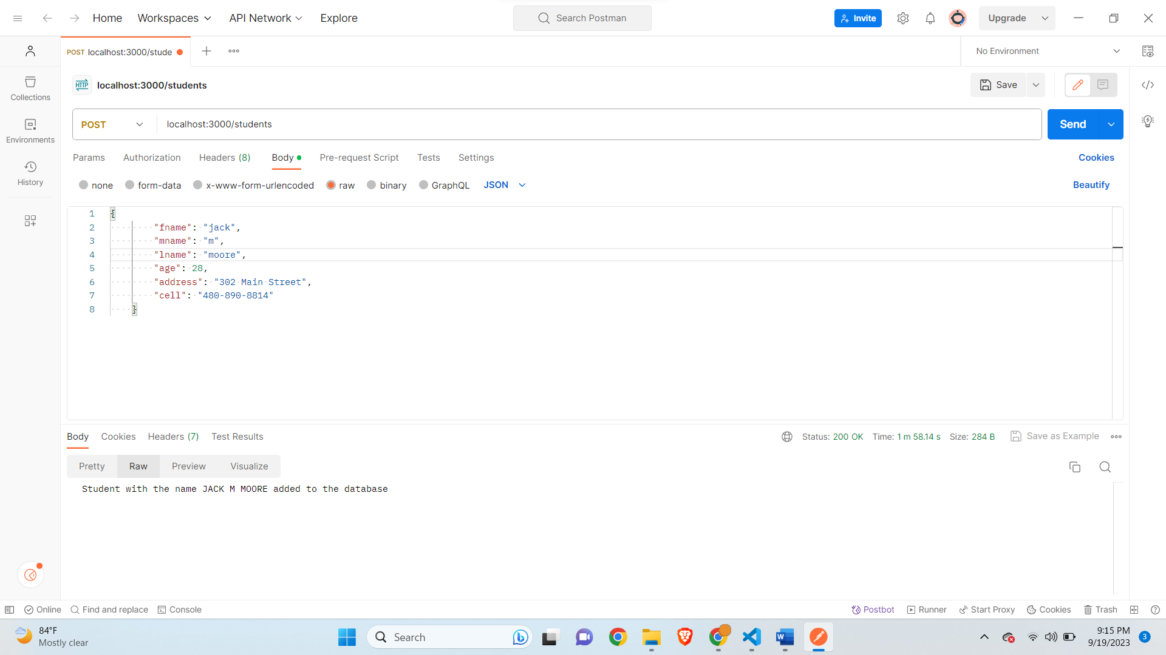

**Get all Students for upperCase-**

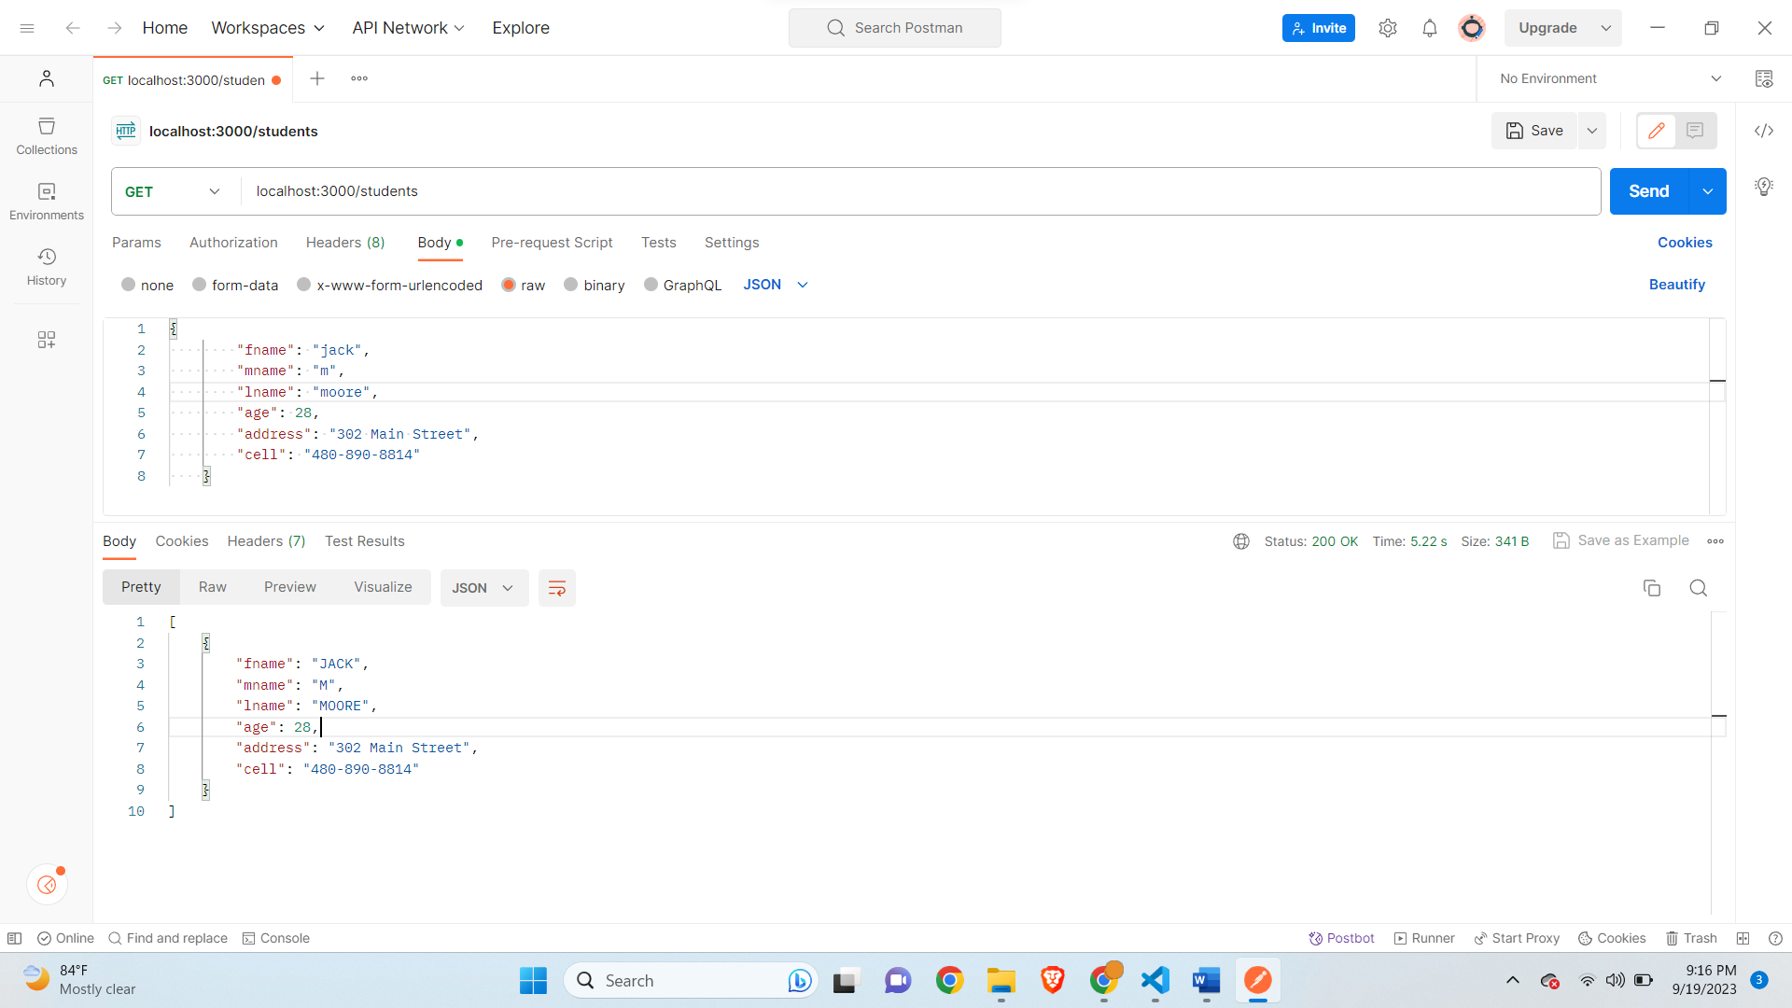

**Admin Check Added-**

**app.js-**

// Name: Saurabh Kale

// ASUID: 1223450319

// Date: 9/24/2023

// require express use or import express

const express = require('express');

const app = express();

const students = []; // array of students objects acting as storage

const bodyParser = require('body-parser');

app.use(bodyParser.json());

//change the name to uppercase

const makeUpperCase = (req, res, next) => {

    const student = req.body;

    if(req.body.fname == undefined || req.body.mname == undefined || req.body.lname == undefined){

        return res.send('Please enter a valid name');

    }

    req.body.fname = student.fname.toUpperCase();

    req.body.mname = student.mname.toUpperCase();

    req.body.lname = student.lname.toUpperCase();

    next();

}

const checkAdmin = (req, res, next) => {

    if(req.query.admin === 'true'){

        next();

    } else{

        res.status(400).send('Should be admin');

    }

}

app.use(makeUpperCase);

const getSpecificStudent = (req, res) => {

    const id = req.params.id;

    const currentStudent = students[id]

    if(currentStudent === undefined){

        res.send(`Student with the ${id} is not found`)

    }

    res.send(`Student with the ${id} is ${currentStudent.fname} ${currentStudent.mname} ${currentStudent.lname}`);

}

const getStudents = (req, res) => {

    res.send(students);

}

const addStudent = (req, res) => {

    const student = req.body;

    students.push(student);

    res.send(`Student with the name ${student.fname} ${student.mname} ${student.lname} added to the database`);

}

const updateStudent = (req, res) => {

    const id = req.params.id;

    const student = req.body;

    students[id] = student;

    res.send(`Student with the id ${id} has been updated`);

}

const deleteStudent = (req, res) => {

    const id = req.params.id;

    const student = students[id];

    students.splice(id, 1);

    res.send(`Student with the id ${id} has been deleted`);

}

//  routes handlers CRUD interfaces

//  for every request, we have a response

app.get('/students/:id',checkAdmin, getSpecificStudent); // get all students functions

app.get('/students', getStudents); // get all students functions

app.post('/students', addStudent); // add student function

app.put('/students/:id', updateStudent); //update student function

app.delete('/students/:id',checkAdmin, deleteStudent); //delete student function

app.use('/', function(req, res, next) {

    console.log('Request Url:' + req.url);

    res.send('Hello');

});

app.listen(3000, () => {

    console.log('Server is running on port 3000');

});

**Get Students-**

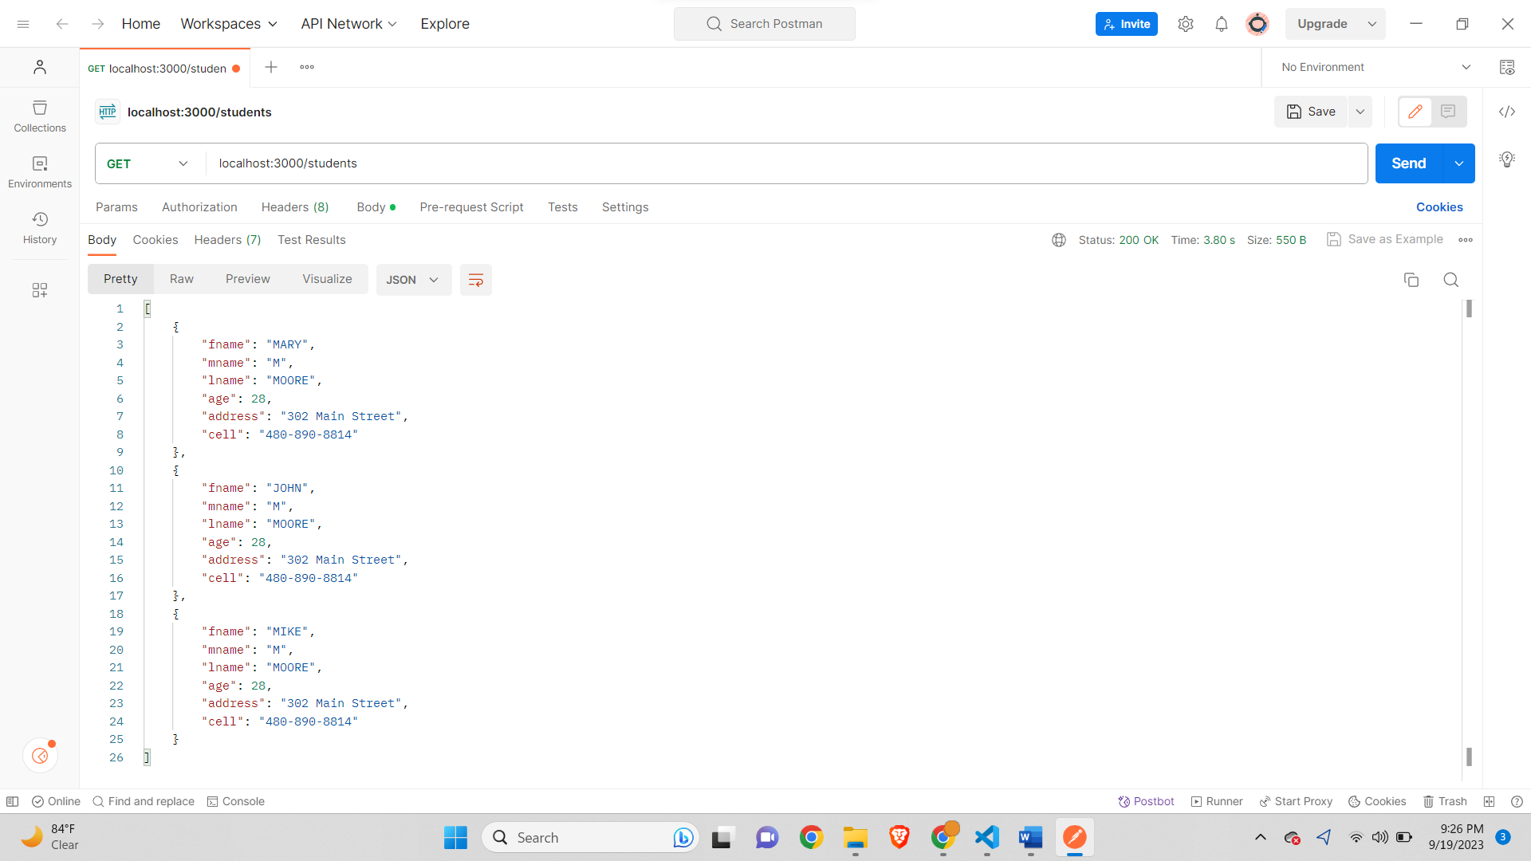

**Should be admin for GET-**

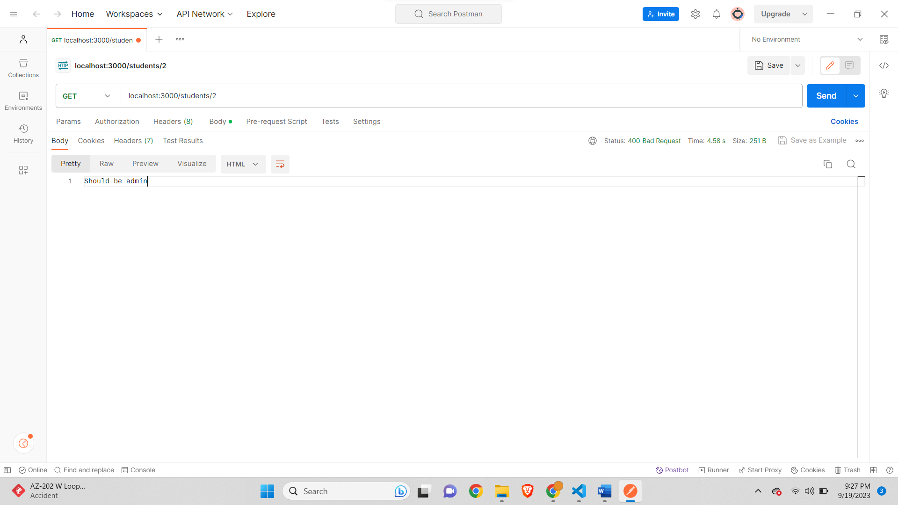

**Should be Admin for DELETE-**



**BookHub-**

**appBookHub.js-**

// Name: Saurabh Kale

// ASUID: 1223450319

// Date: 9/24/2023

// require express use or import express

const express = require('express');

const app = express();

const books = []; // array of book objects acting as storage

const bodyParser = require('body-parser');

app.use(bodyParser.json());

const checkAdmin = (req, res, next) => {

    console.log(req.query)

    if(req.query.admin === 'true'){

        next();

    } else{

        res.status(400).send('Should be admin');

    }

}

//Routes

app.get('/', (req,res) => {

    res.send(`Welcome to BookHub!`);

});

app.post('/cart/add', checkAdmin, (req,res) => {

    console.log(req.body)

    if(req.body.book!=undefined){

        books.push(req.body.book)

        res.send(`Book added New List- ${books}`);

    }

    else{

        res.send('Failed to add Book');

    }

});

app.delete('/cart/remove', checkAdmin, (req,res)=>{

    res.send(`All Book List removed Succesfully`)

})

app.delete('/cart/remove/:id', checkAdmin, (req,res)=>{

    const id = req.params.id;

    const currentBook = books[id]

    if(currentBook != undefined){

        books.splice(id, 1);

        res.send(`Book Removed New List- ${books}`);

    }

    else{

        res.send(`Book with the ${id} is not found`)

    }

})

app.listen(3000, () => {

    console.log('Server is running on port 3000');

});

**Default Route-**

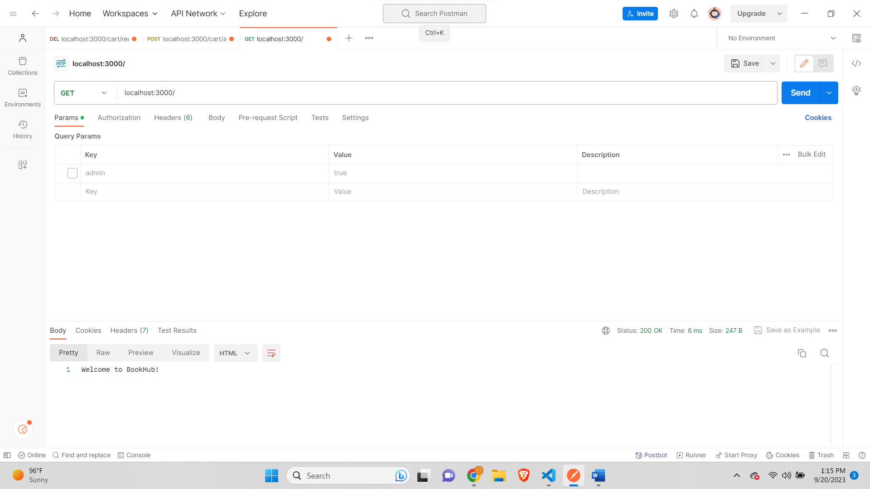

**Add Book route with admin true-**

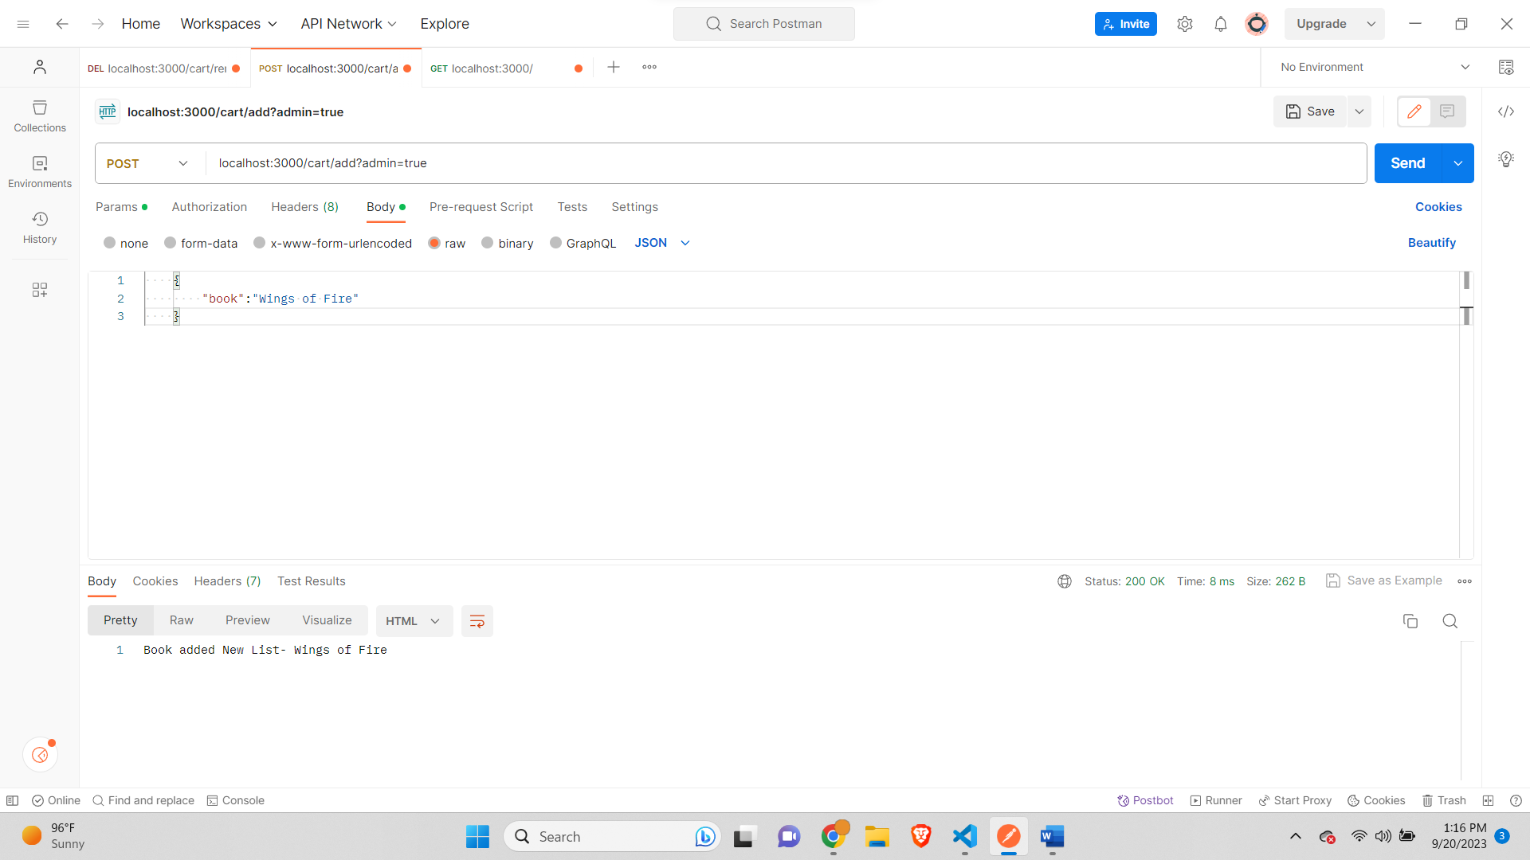

**Add Book with no admin-**

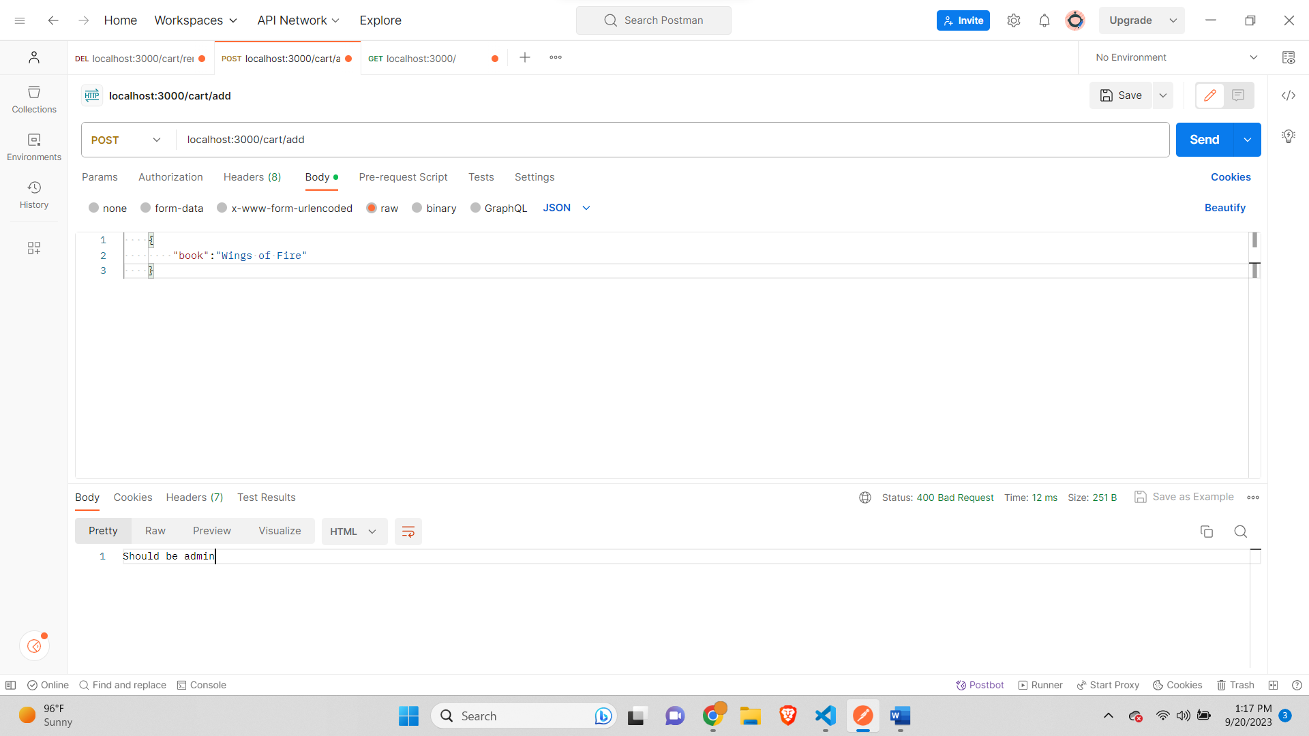

**All Books added-**

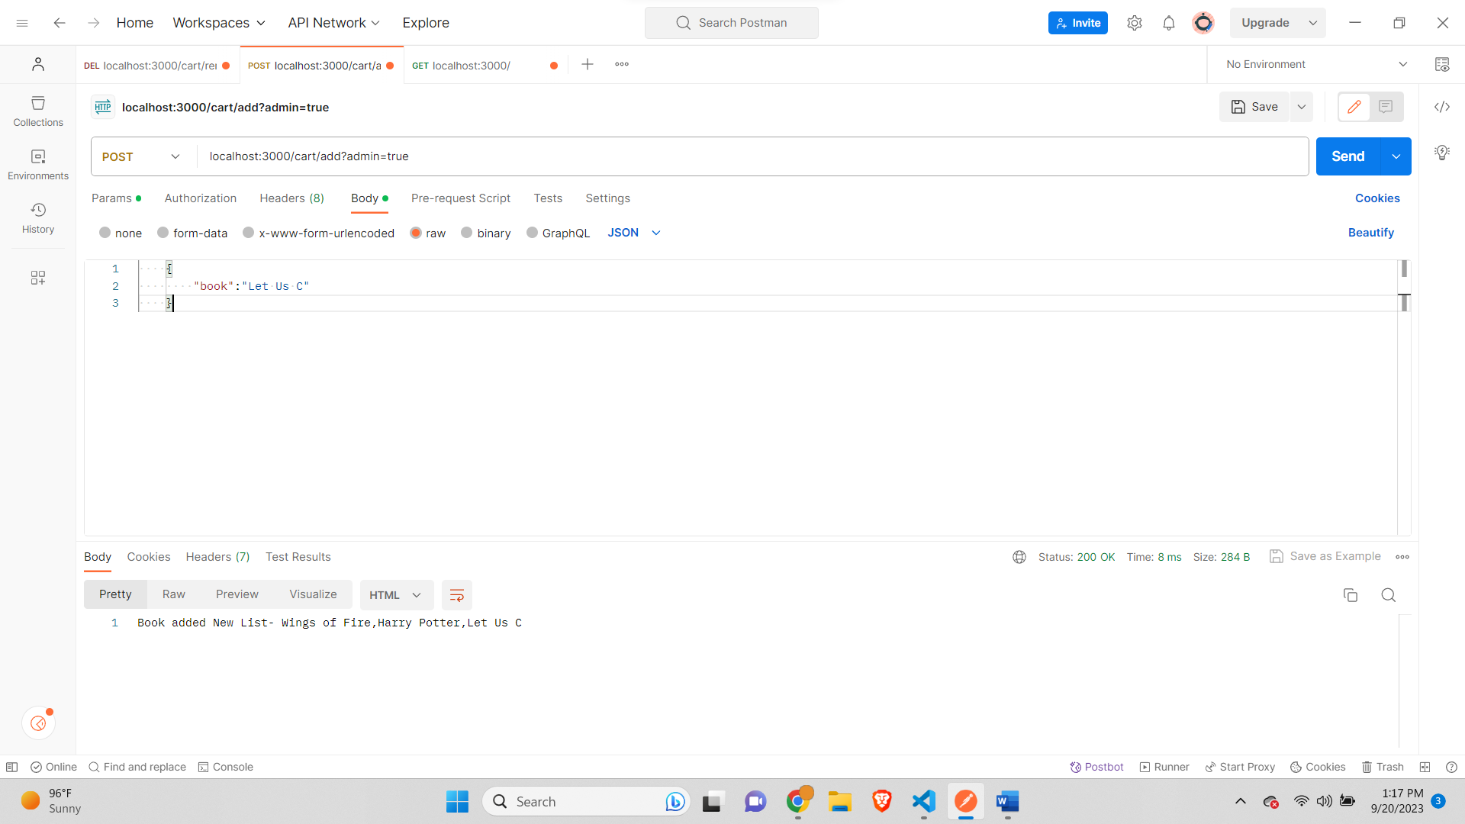

**Delete book out of Index-**

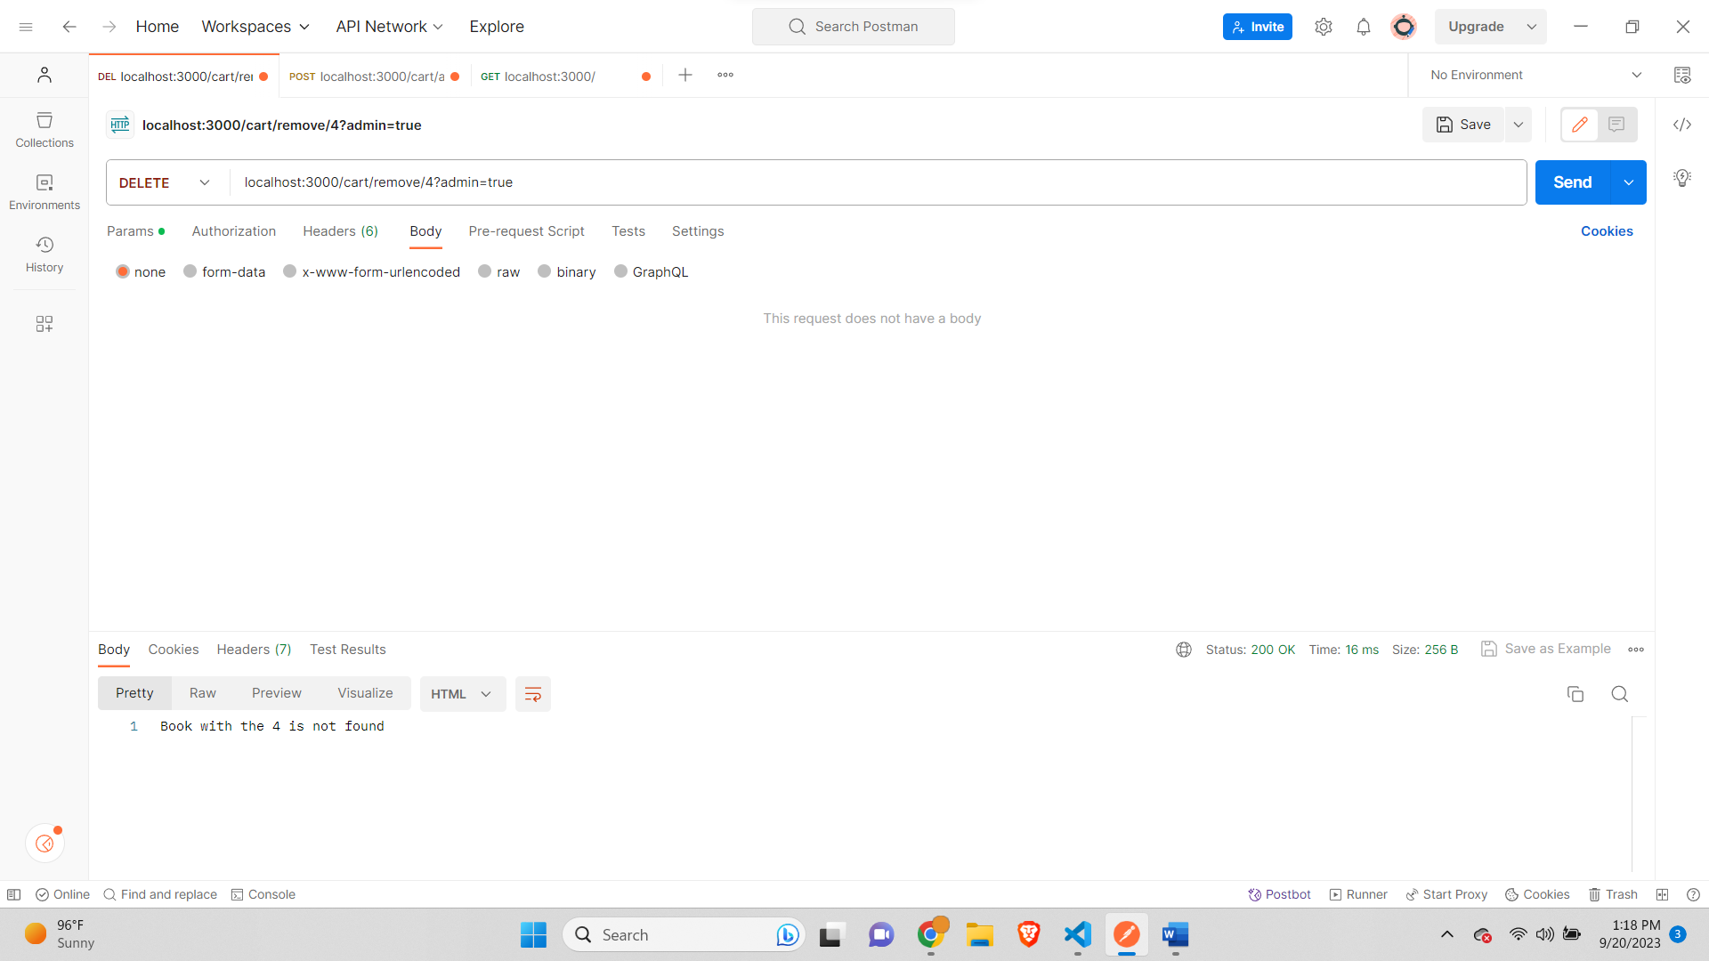

**Delete book with proper Index-**

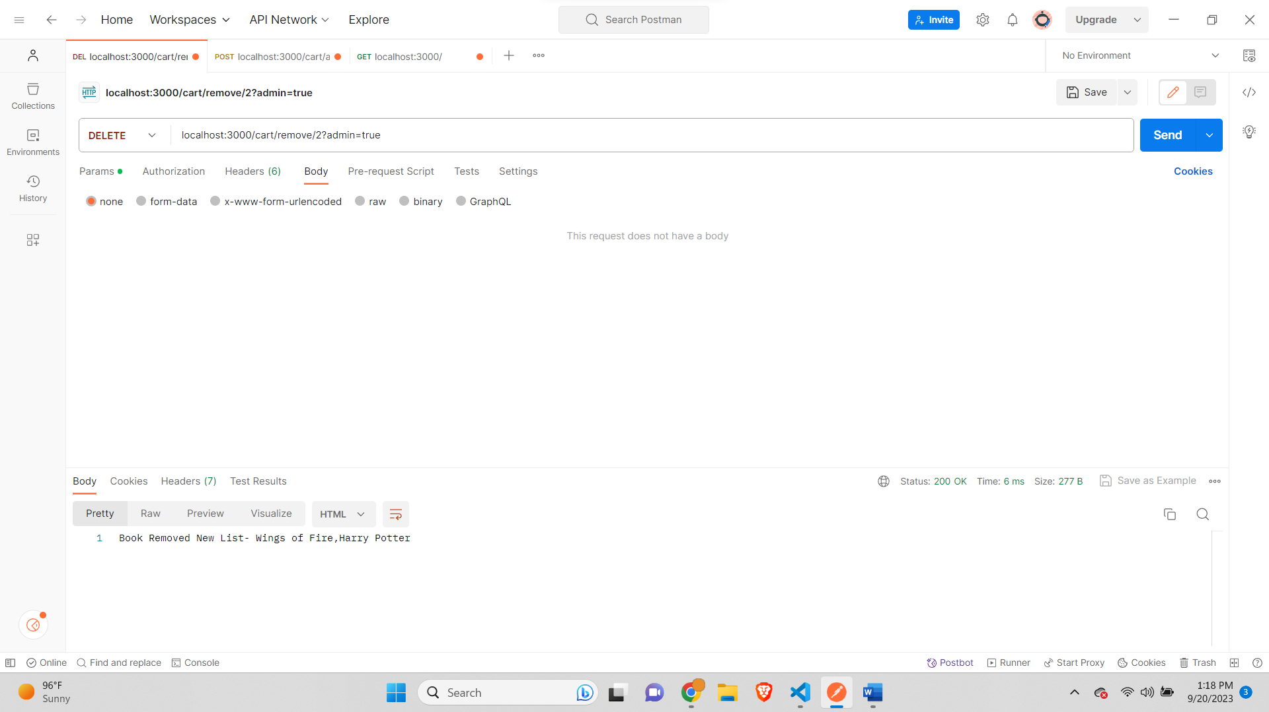

**Delete book with no admin-**

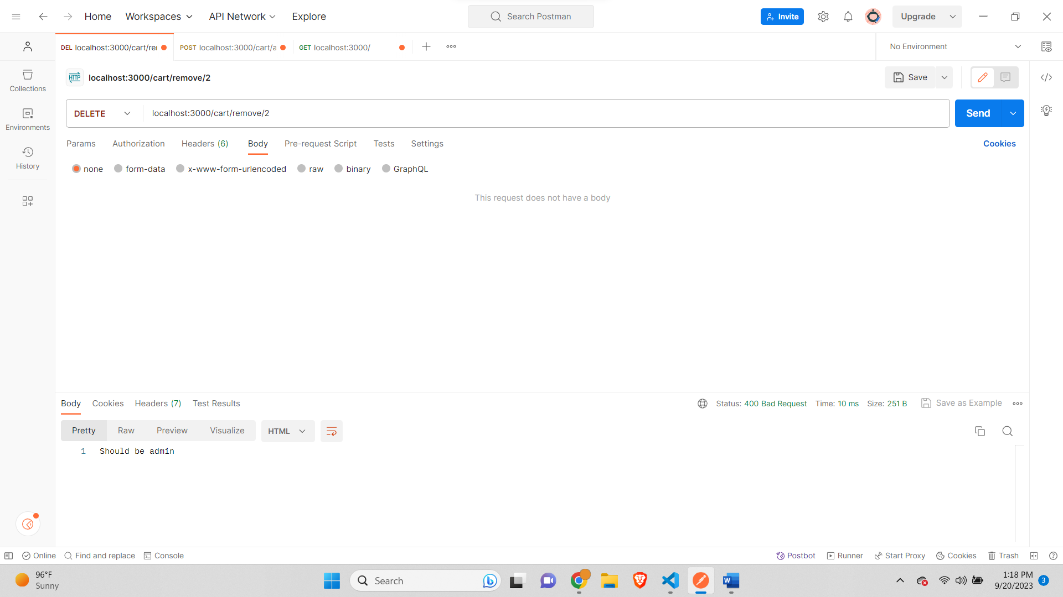

**Part C:**

**Get Home-**

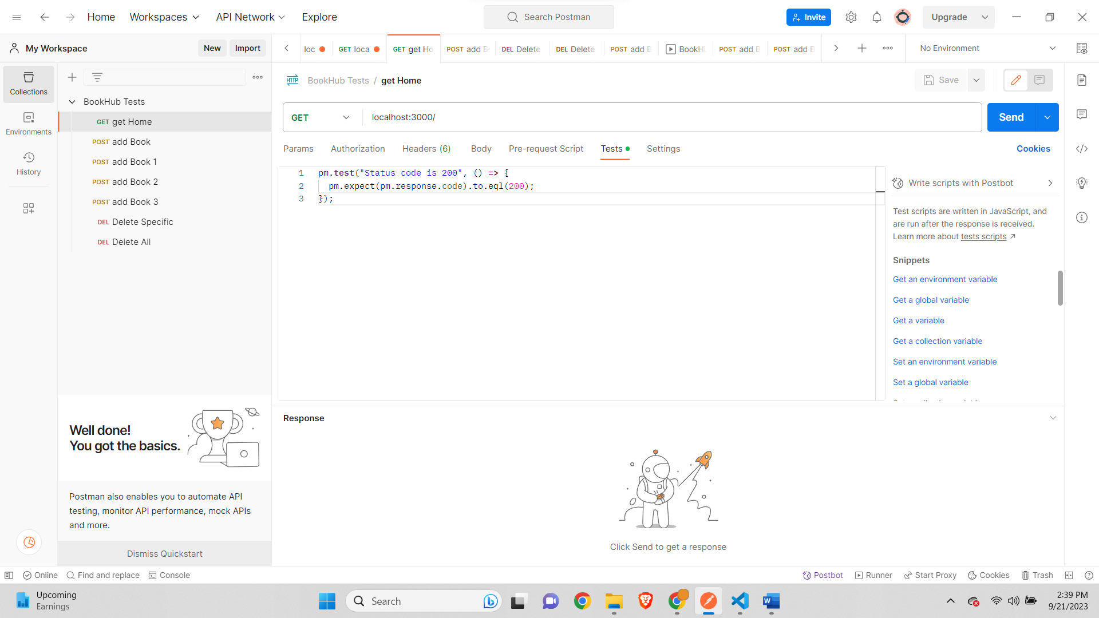

**POST add Book-**

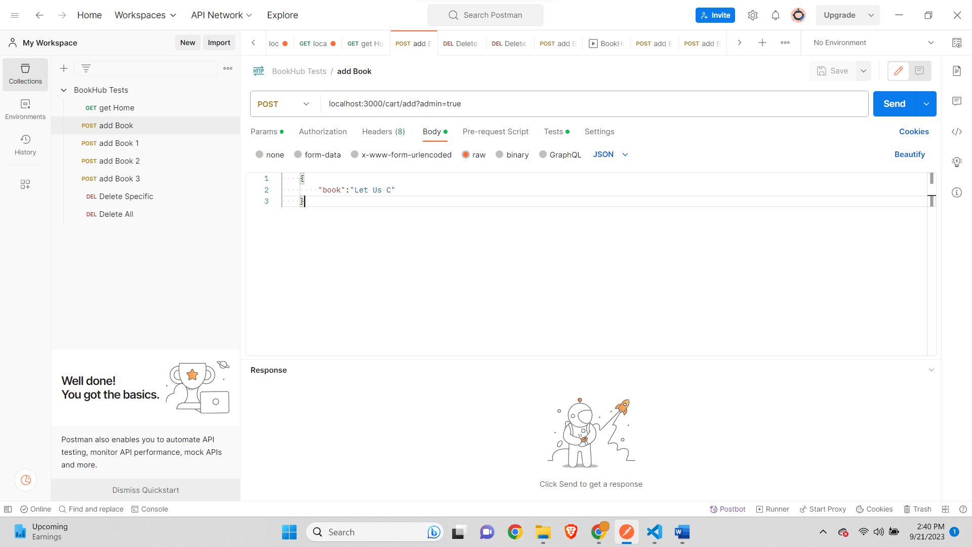

**POST add Book 1-**

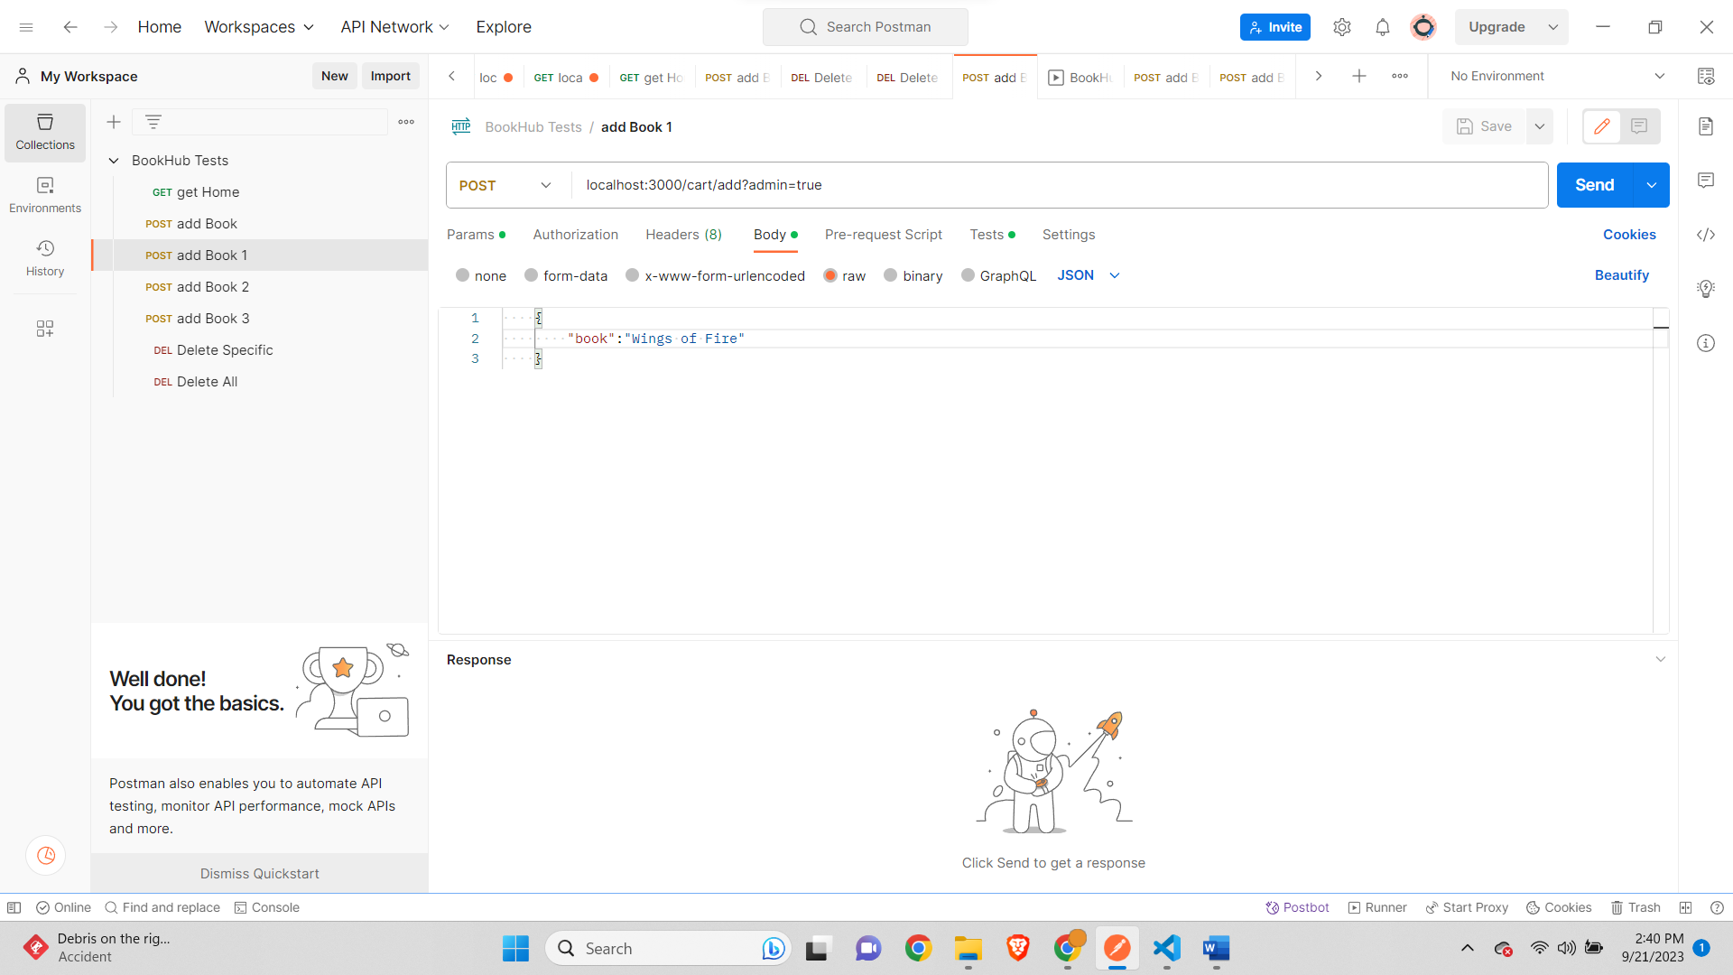

**POST add Book 2-**

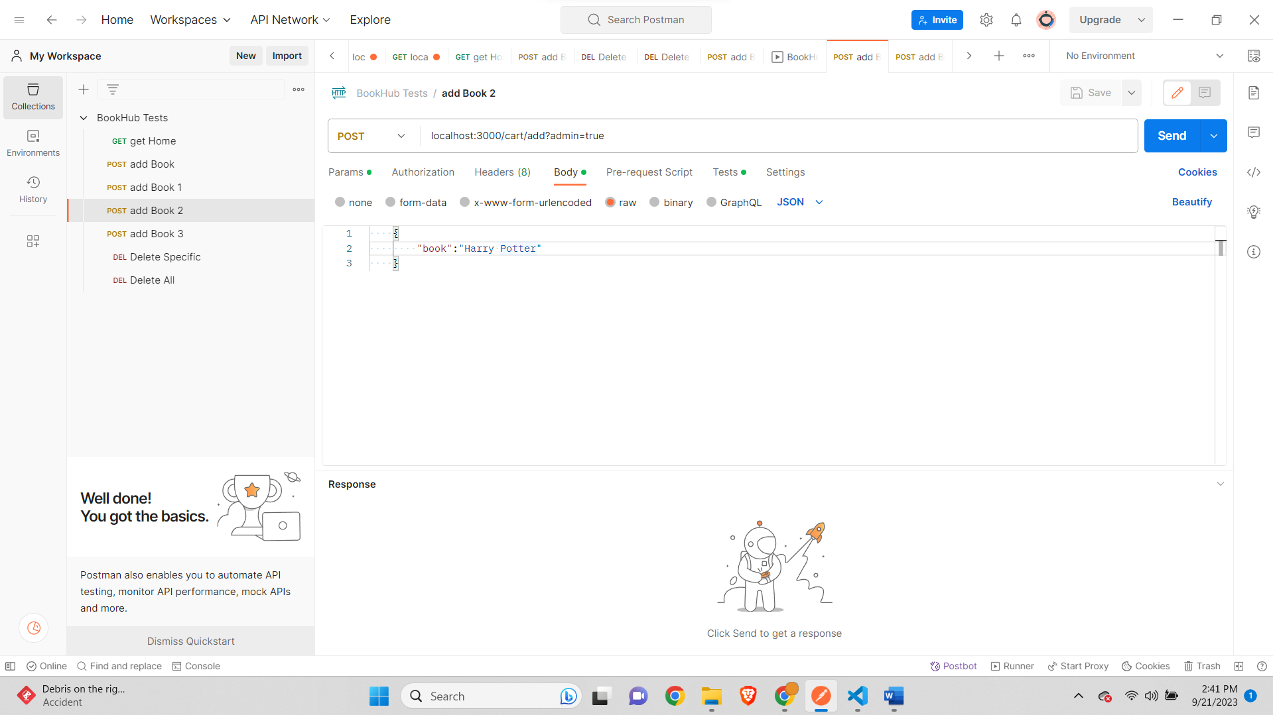

**POST add Book 3-**

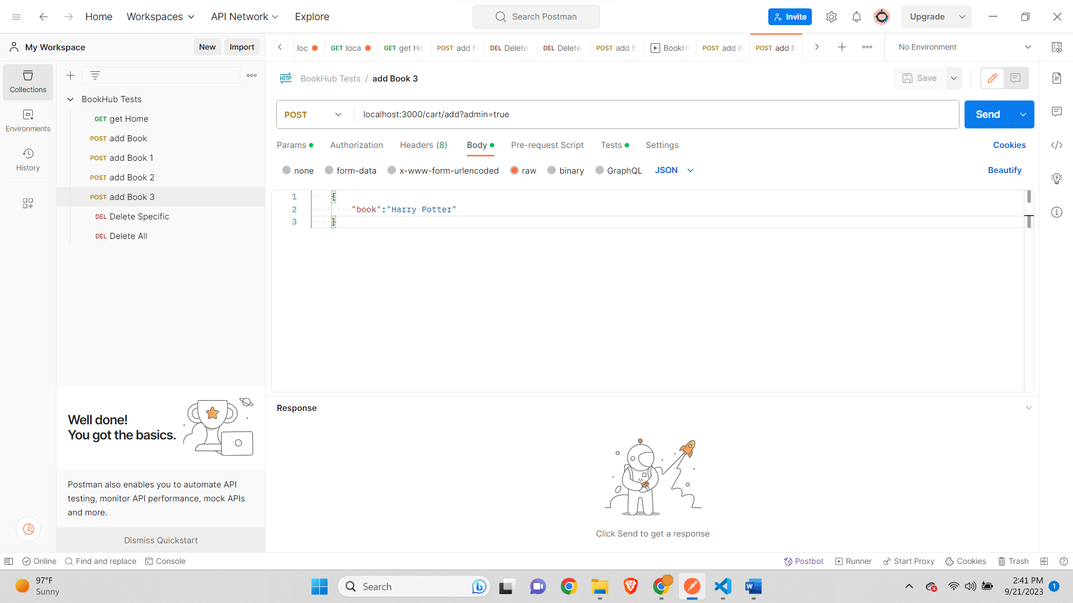

**DELETE Delete Specific-**

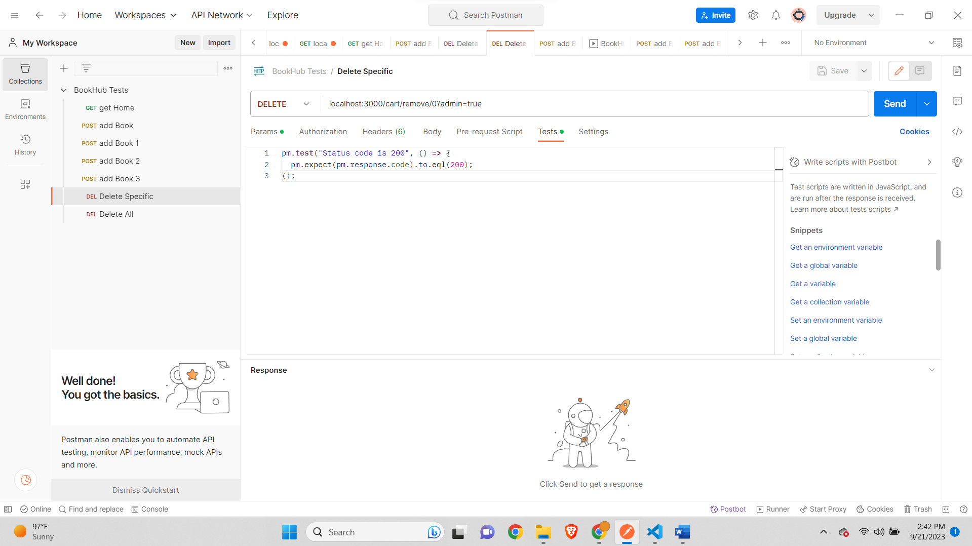

**Delete Delete All-**

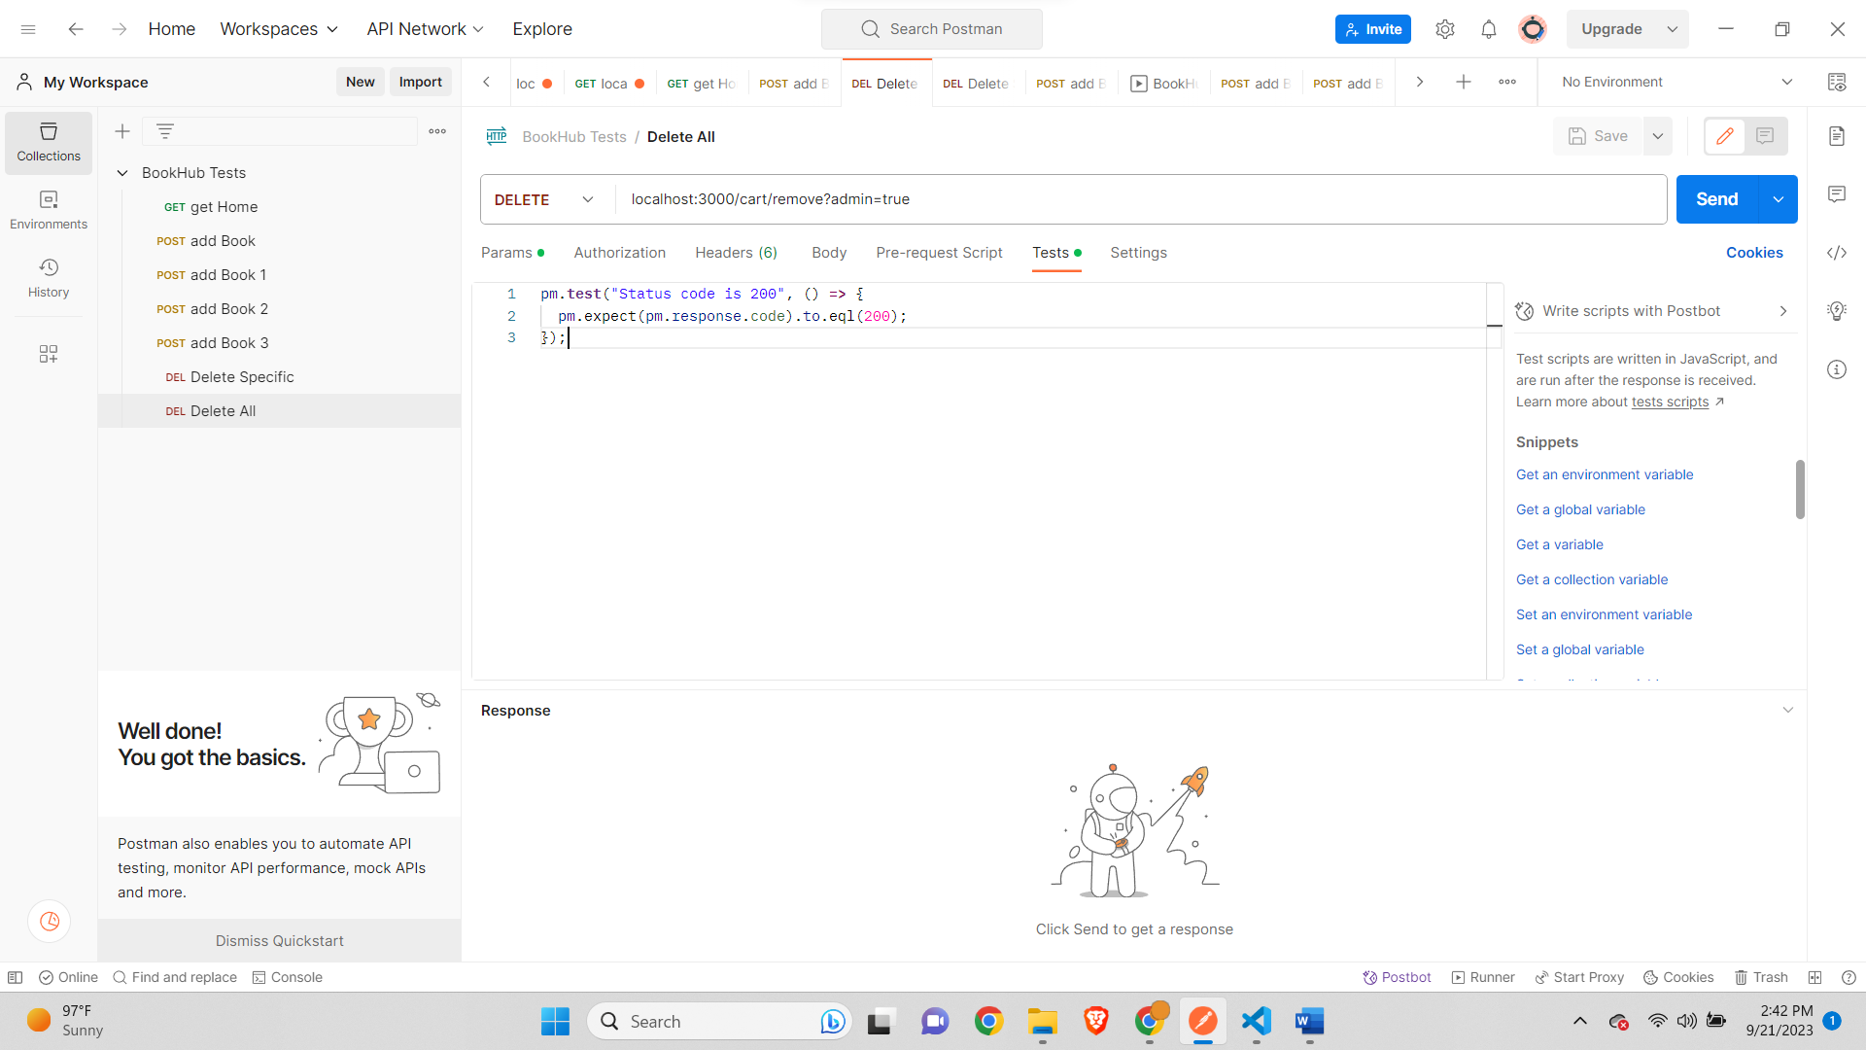

**Run Results-**

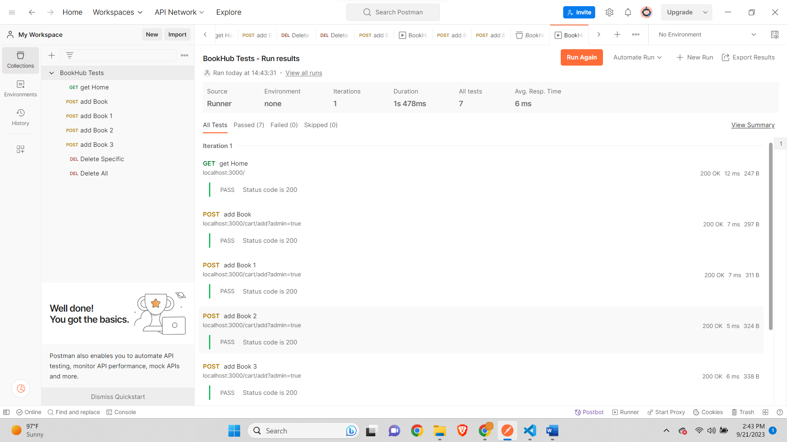

**Remaining Test Results-**

